PROJECT

Step 1: Create a VPC

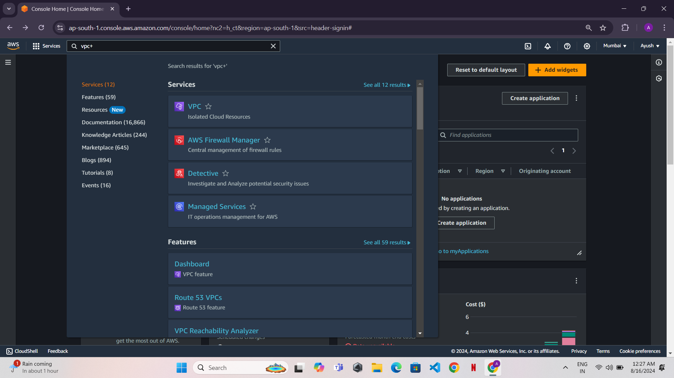

* Go to the VPC Dashboard in the AWS Management Console.
* Click Create VPC.

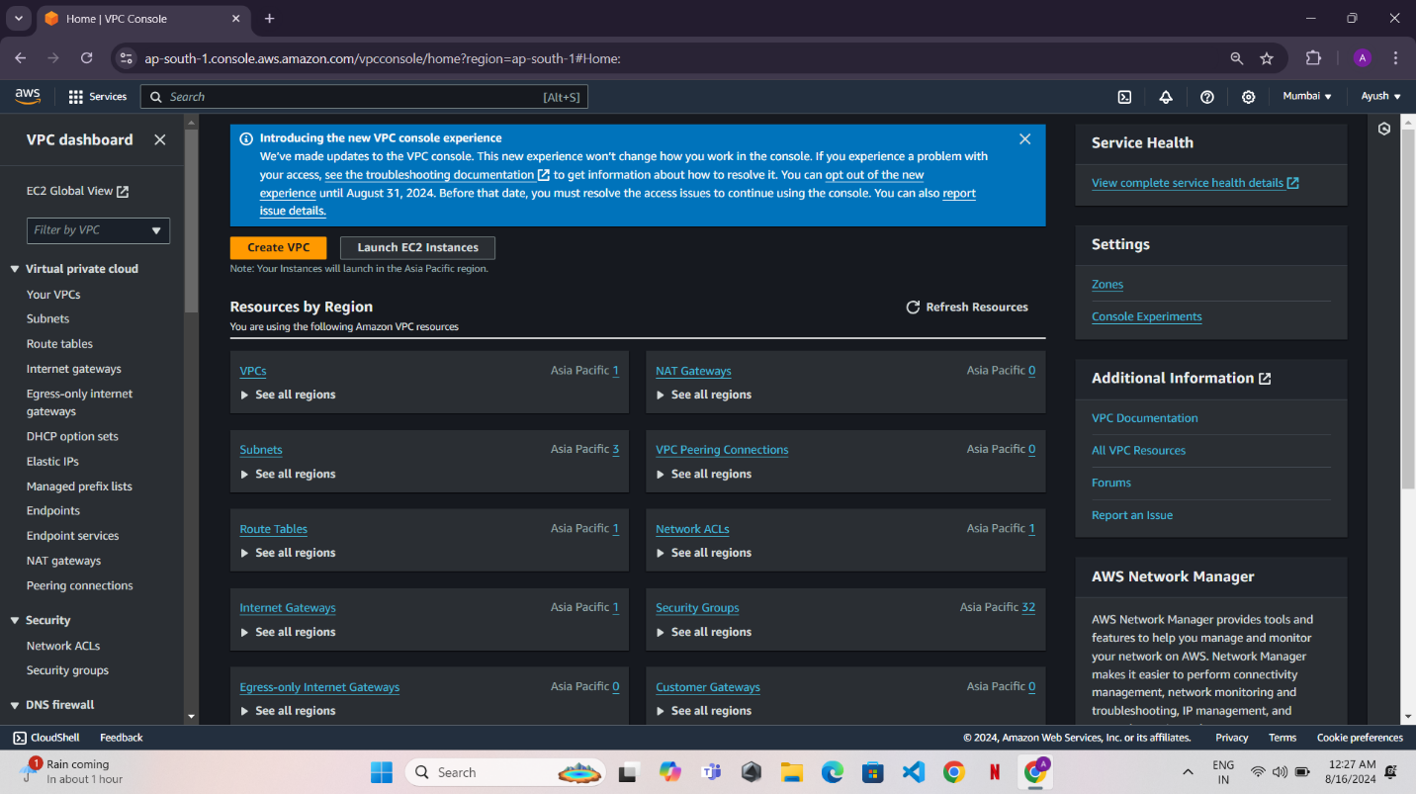

* Name the VPC and set the IPv4 CIDR block (e.g., 10. 0.0.0/16).

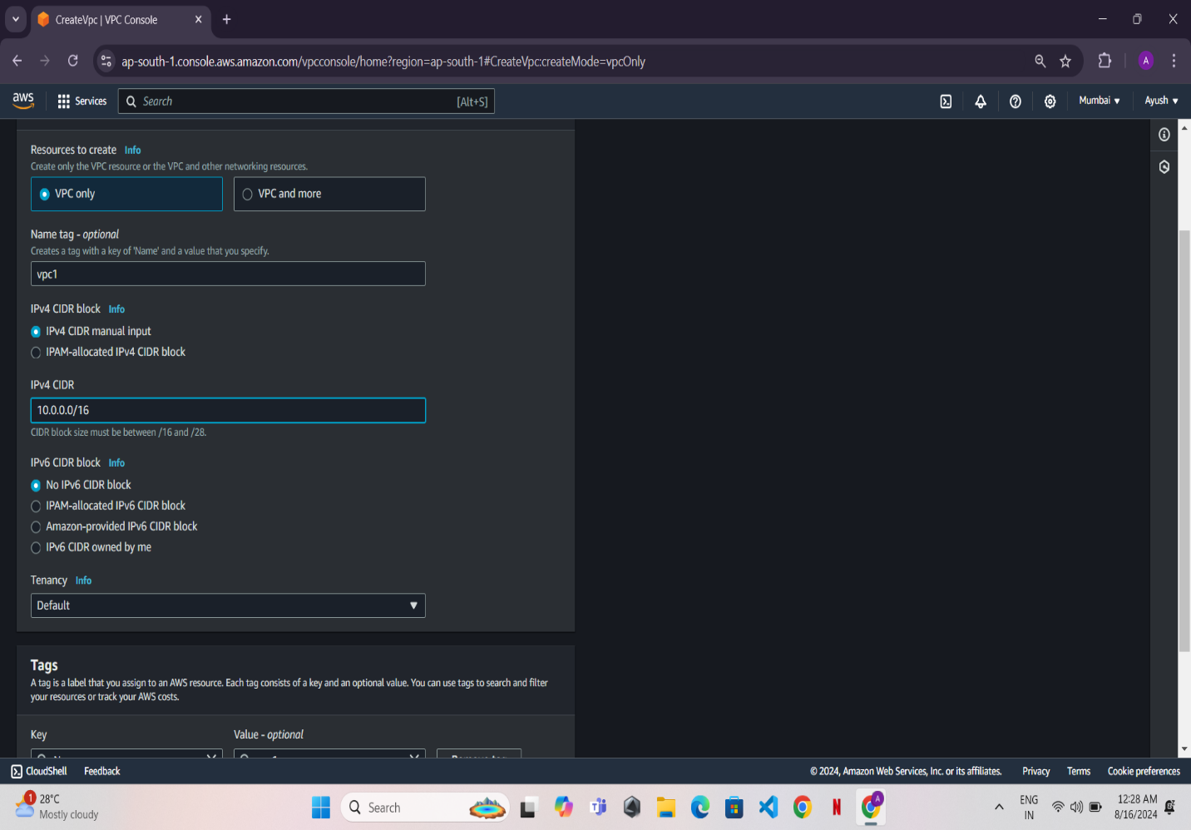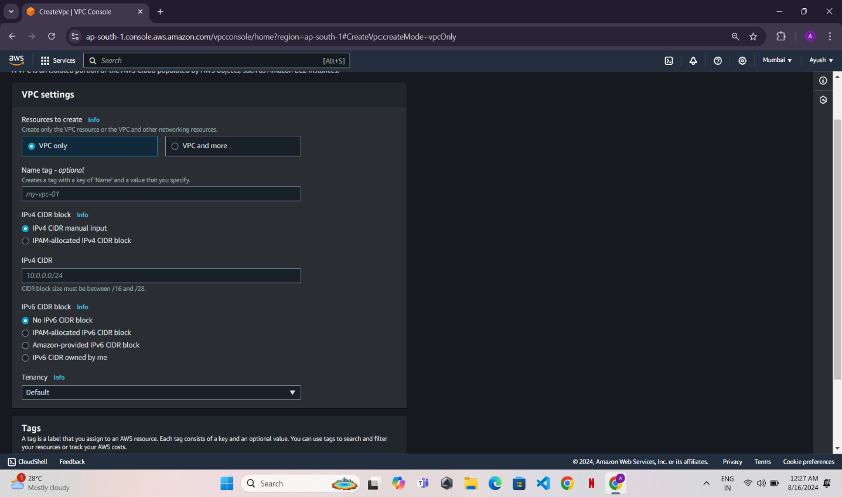

* Leave the other settings as default or modify as needed. Click **Create VPC**.

Step 2: Create 3 Subnets

* Click **Create Subnet**.

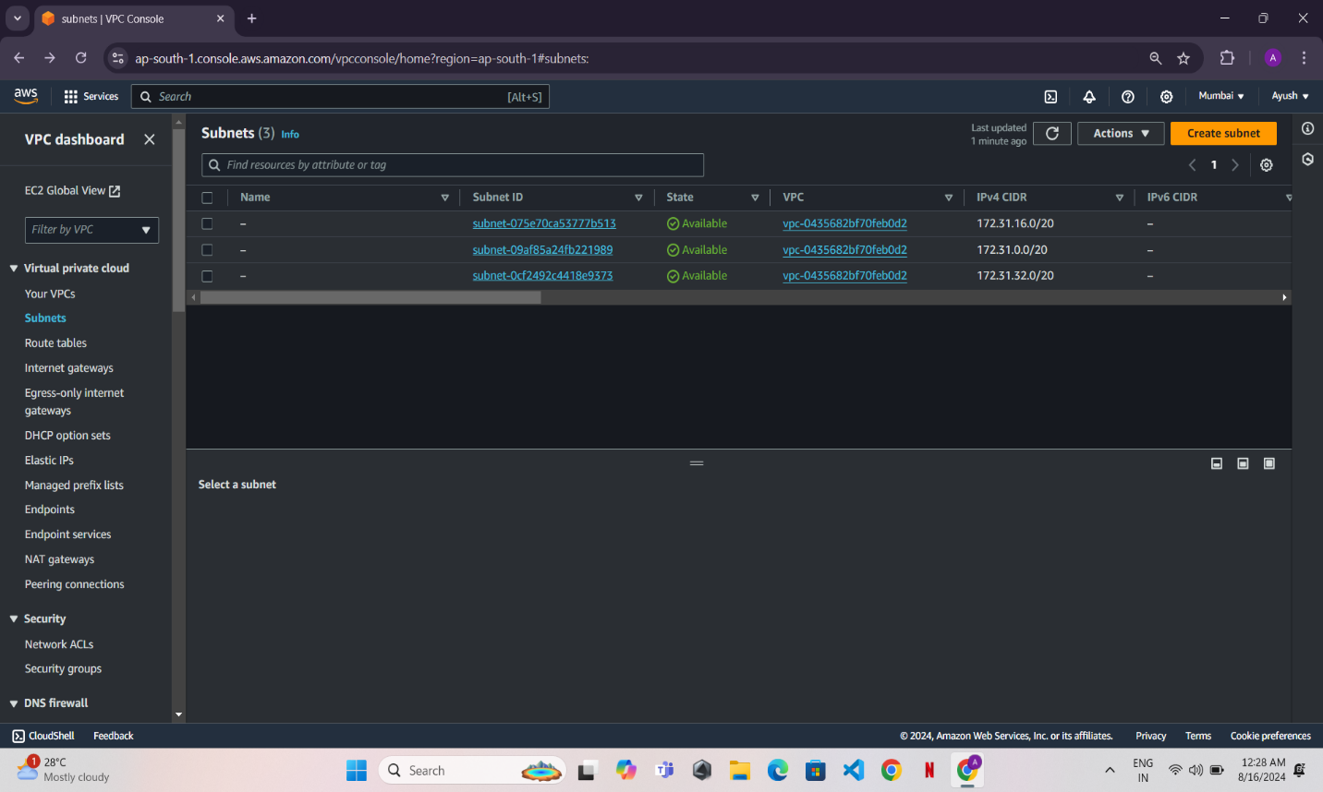

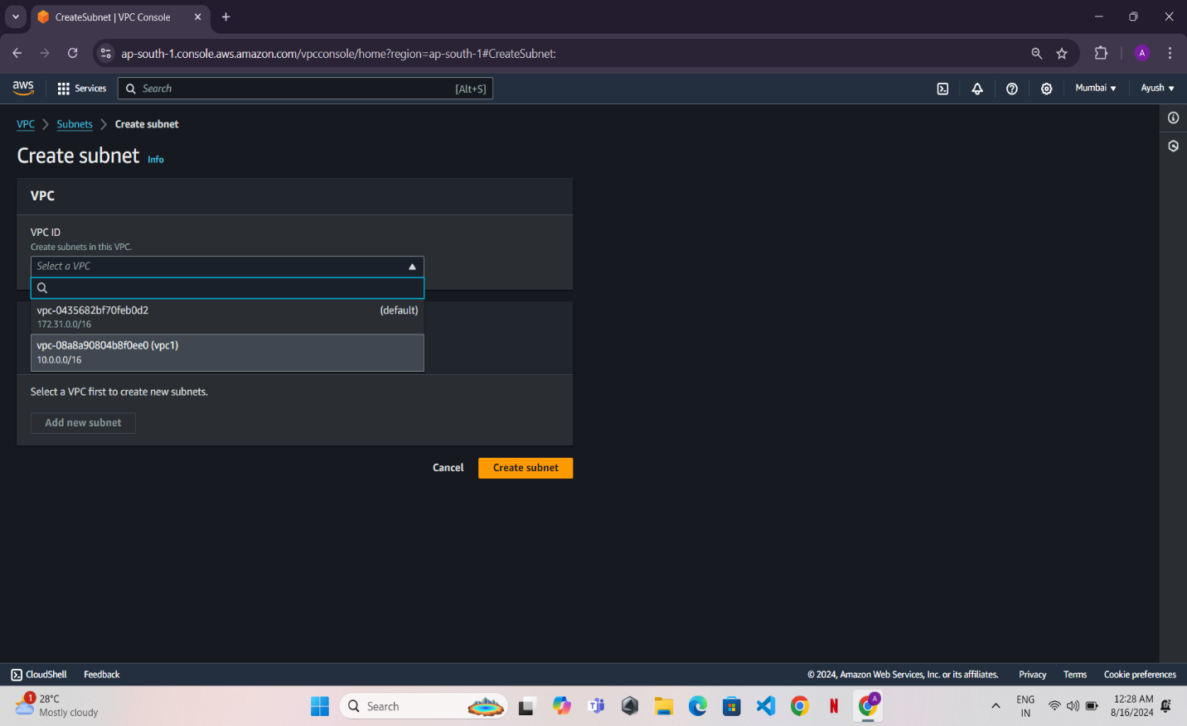

* **Select the VPC you created earlier**.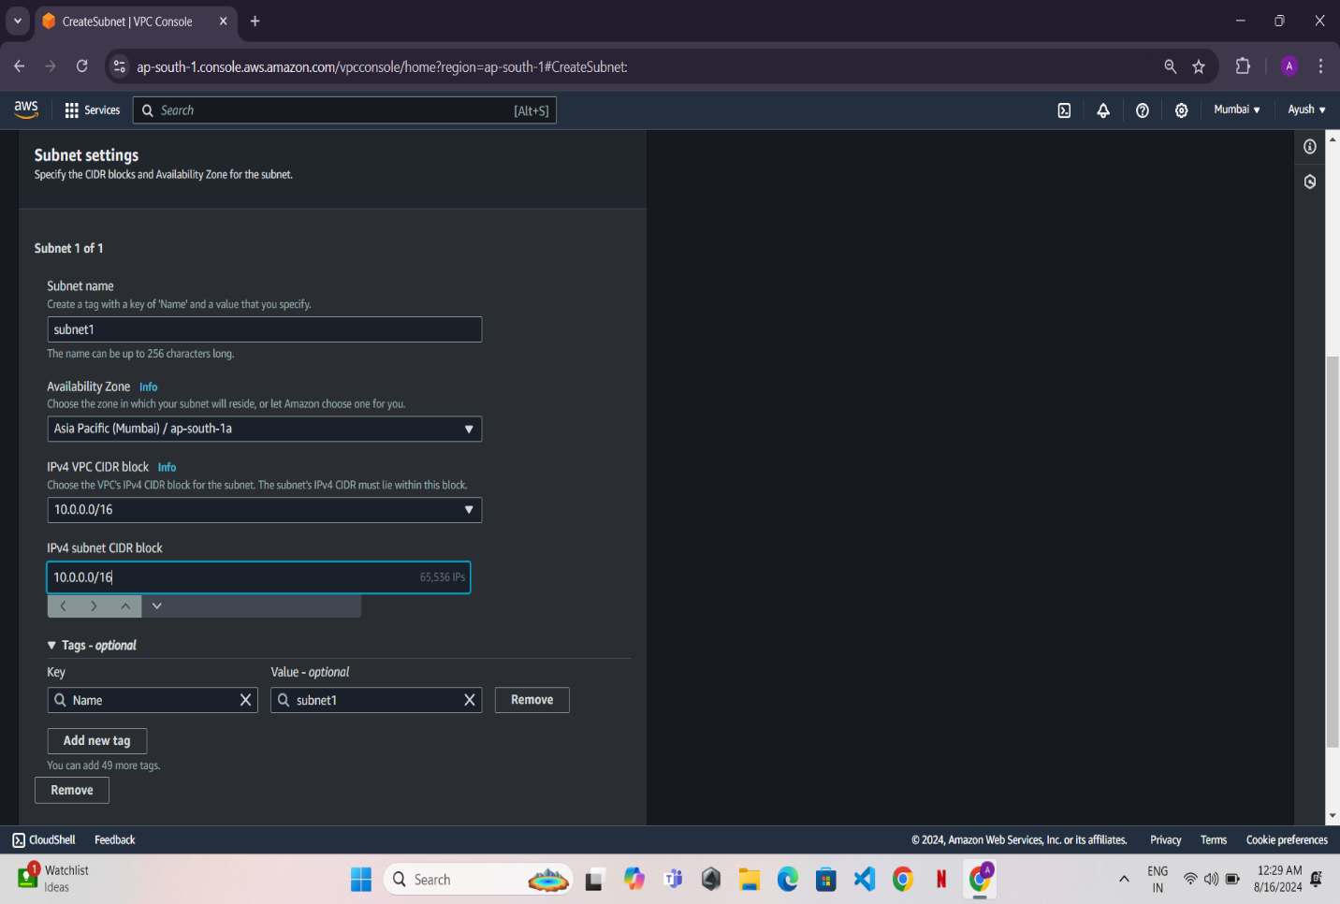

Create three subnets with the following details:

* Subnet 1: 10.0.1.0/24 (Public Subnet)

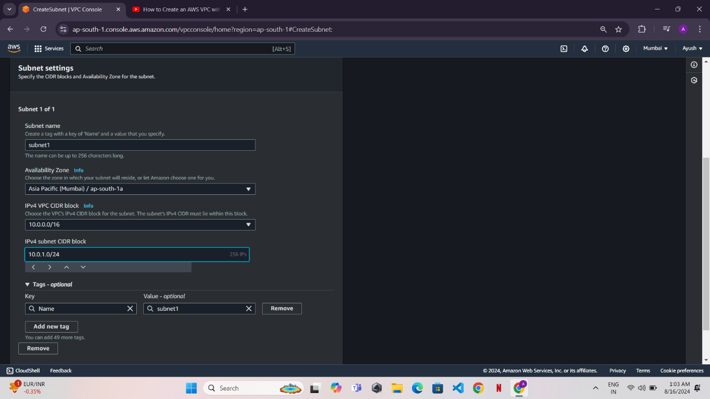

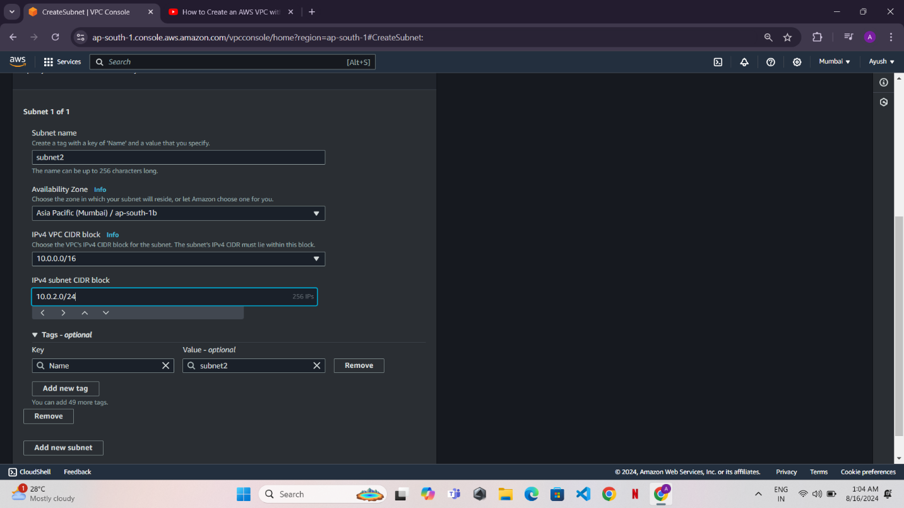

* **Subnet 2: 10.0.2.0/24 (Private Subnet)**

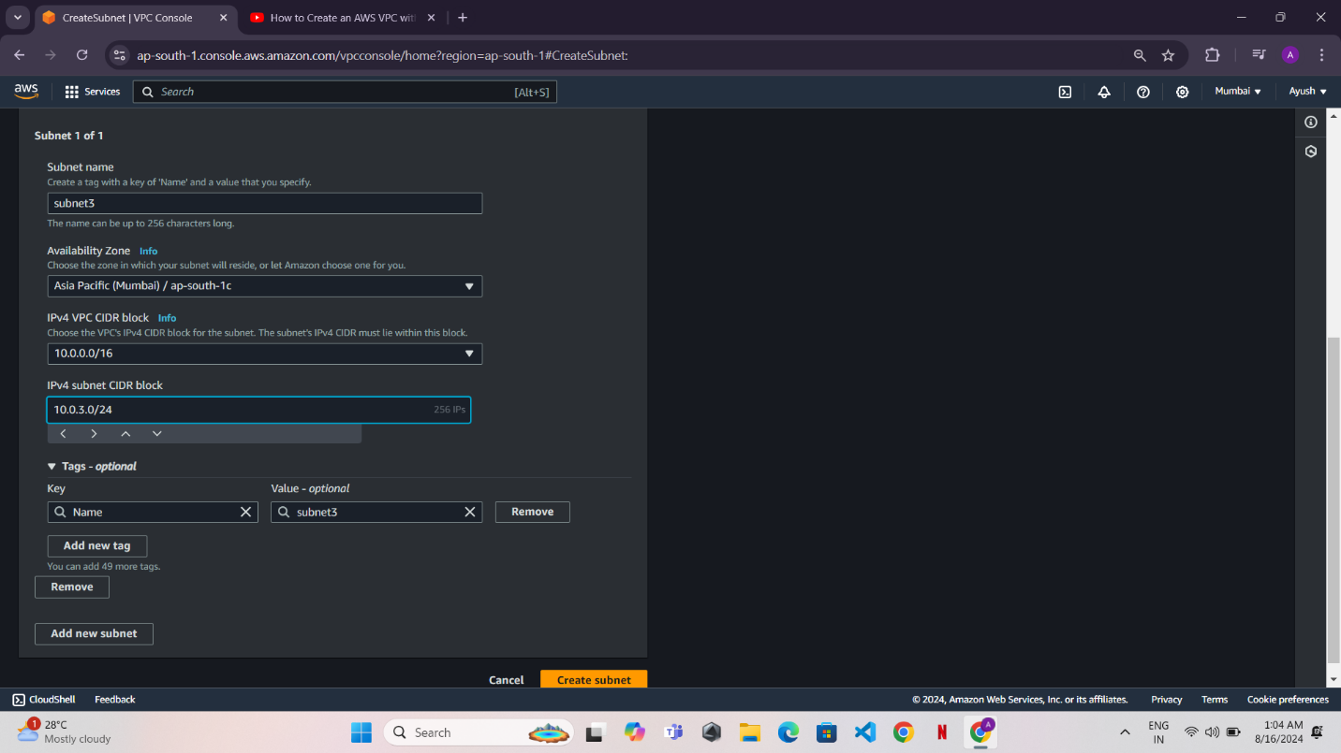

* **Subnet 3: 10.0.3.0/24 (Private Subnet)**

**Step 3: Create and Attach an Internet Gateway**

* Go to the Internet Gateways section in the VPC Dashboard.

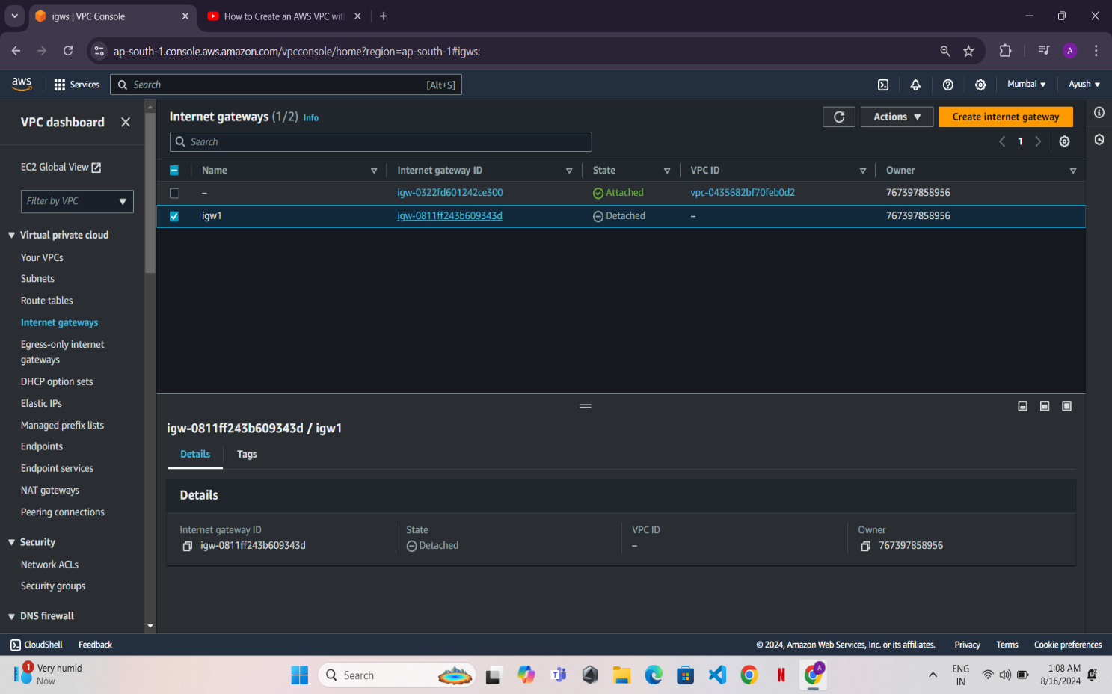

* Click Create Internet Gateway, name it, and click Create.

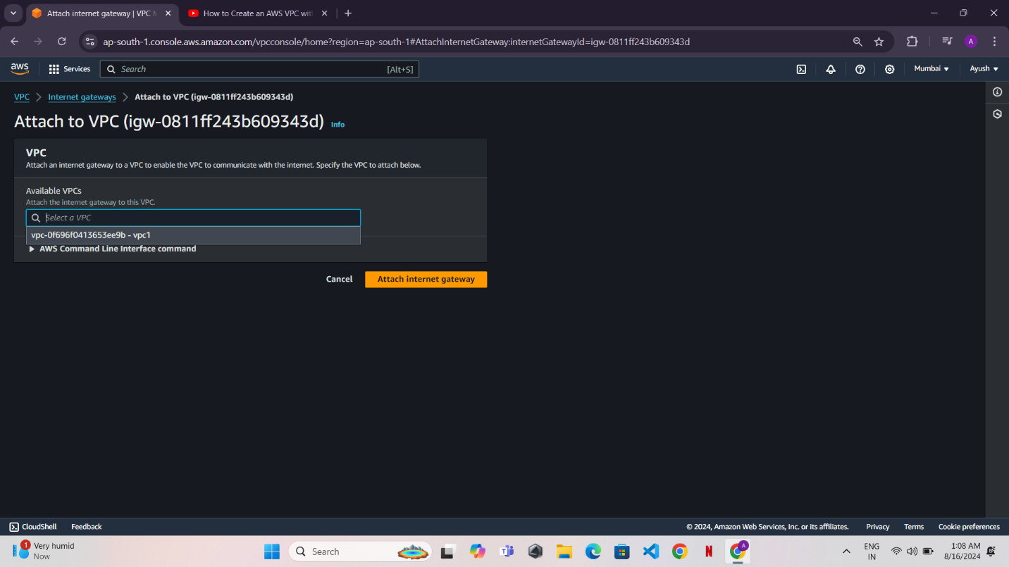

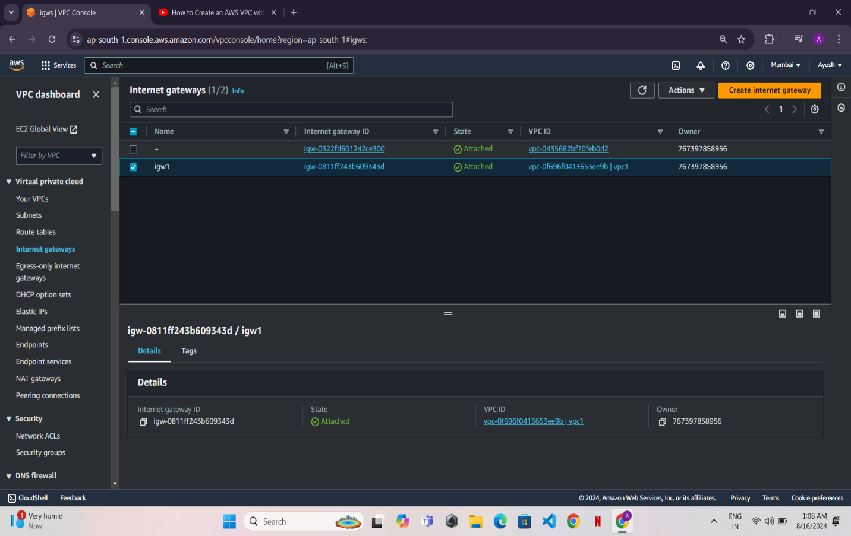

* Select the newly created Internet Gateway, click Actions, and choose Attach to VPC. Select your VPC.

Step 4: Create a Route Table and Associate Subnets

* Go to Route Tables in the VPC Dashboard.

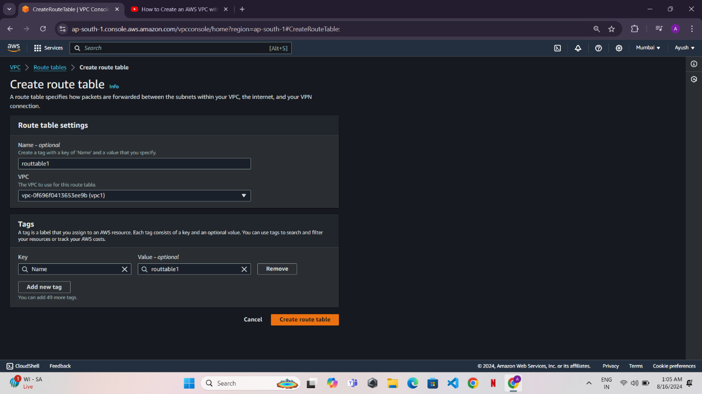

* Click Create Route Table, name it, and associate it with your VPC.

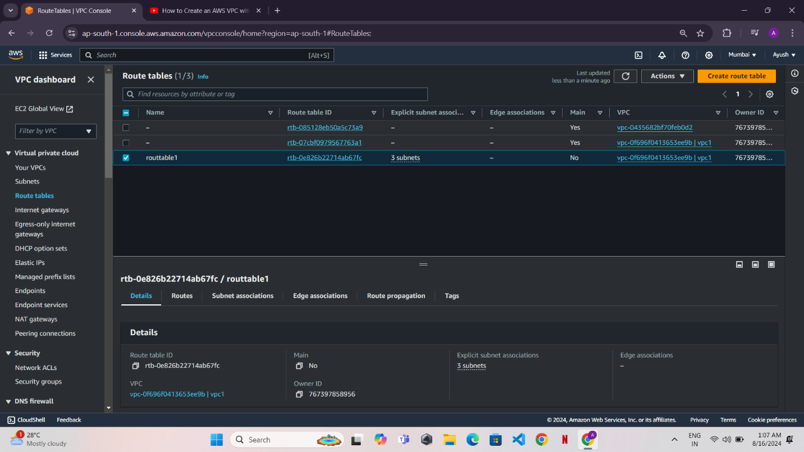



* Associate Subnets: Go to the Subnet Associations tab, click Edit Subnet Associations, and associate the public subnet.

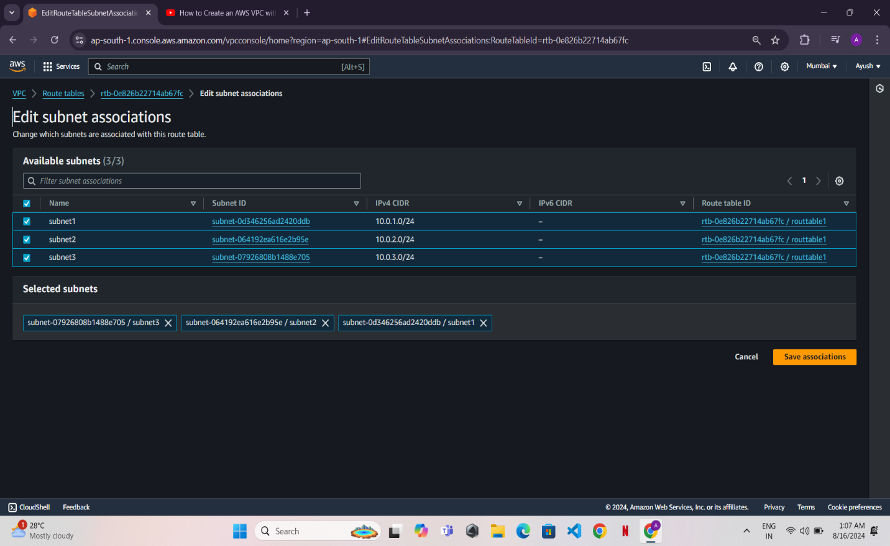

Step 5: Launch a Windows EC2 Instance

* Go to the EC2 Dashboard and click Launch Instance.

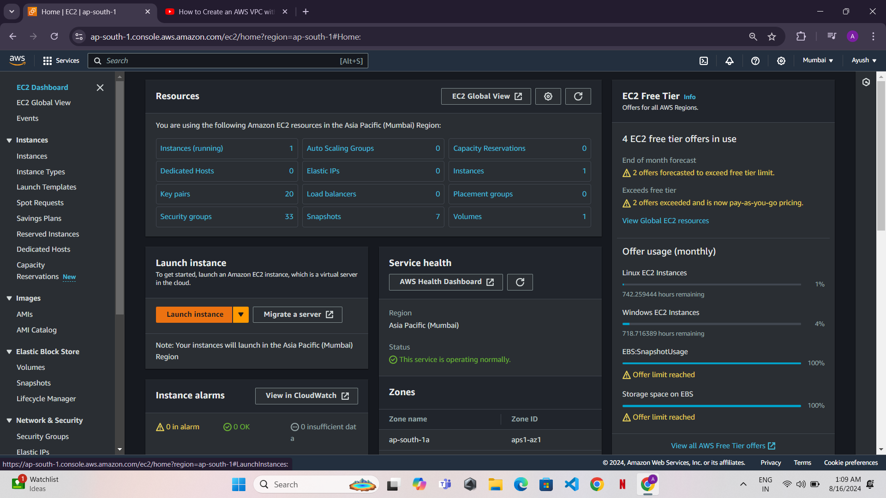



* Choose AMI: Select a Windows Server AMI (e.g., "Microsoft Windows Server 2019 Base").

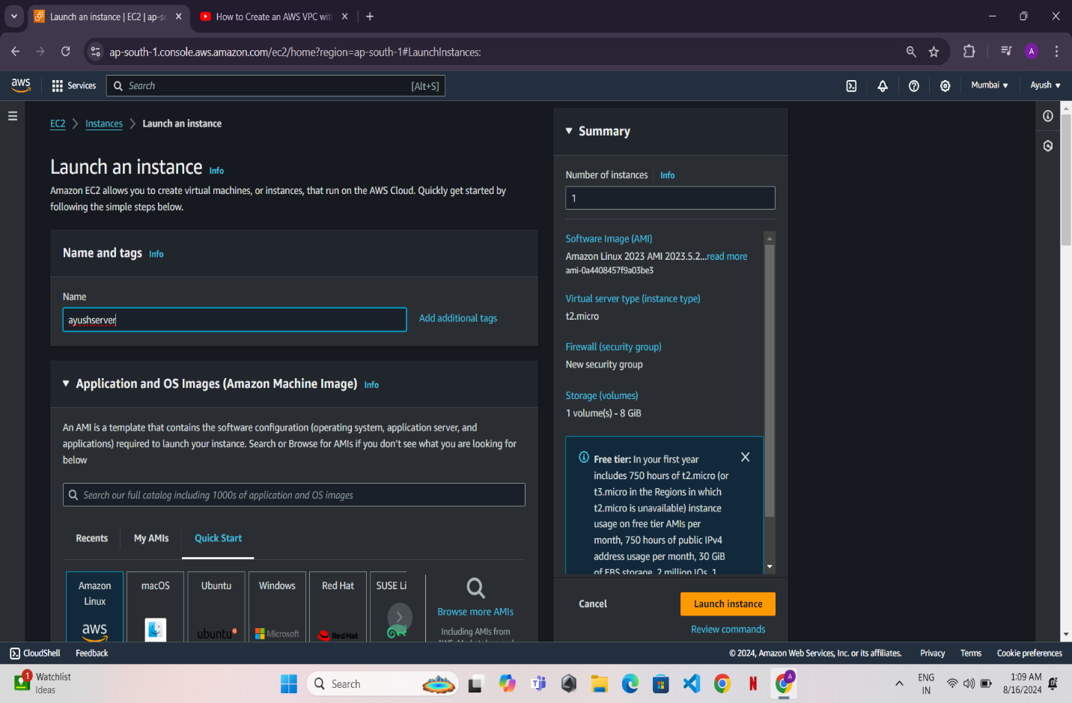

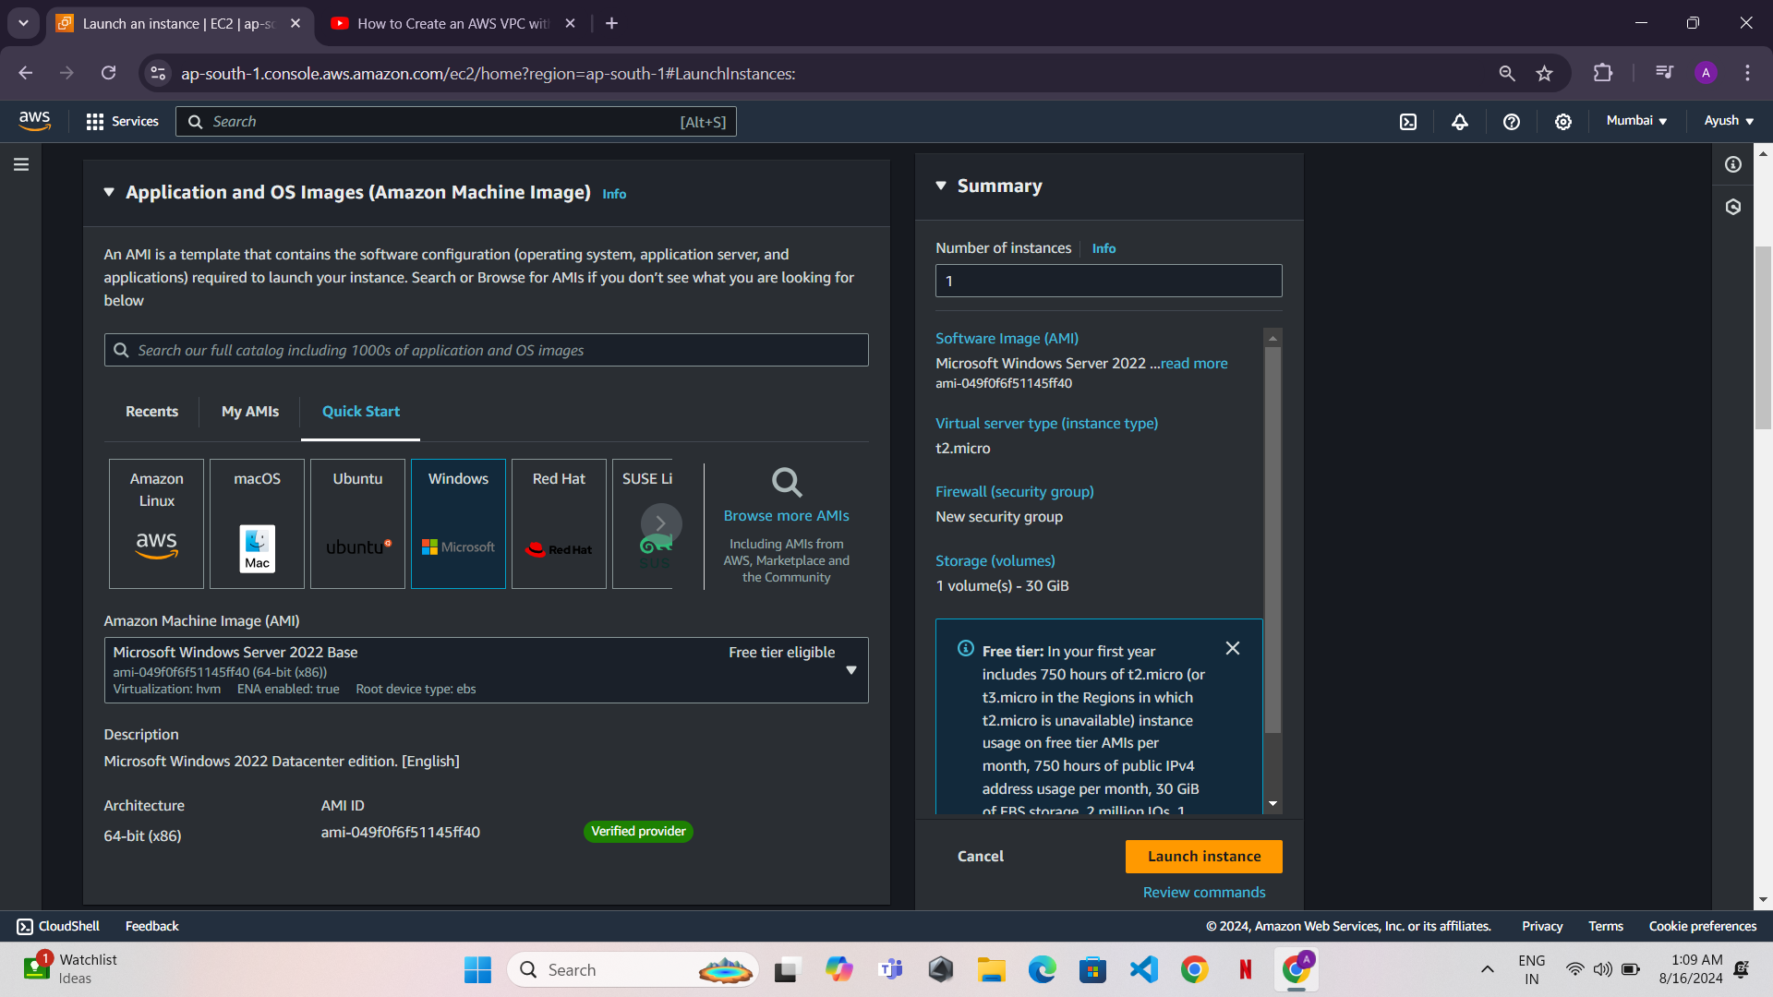



* Instance Type: Choose an instance type (e.g., t2.micro).

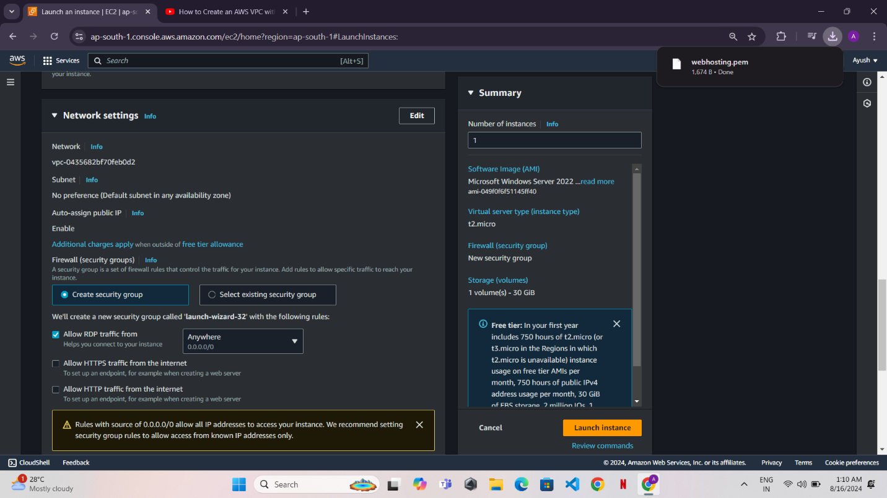

Configure Instance Details:

* Network: Select your VPC.
* Subnet: Select the public subnet.
* Auto-assign Public IP: Enable it.

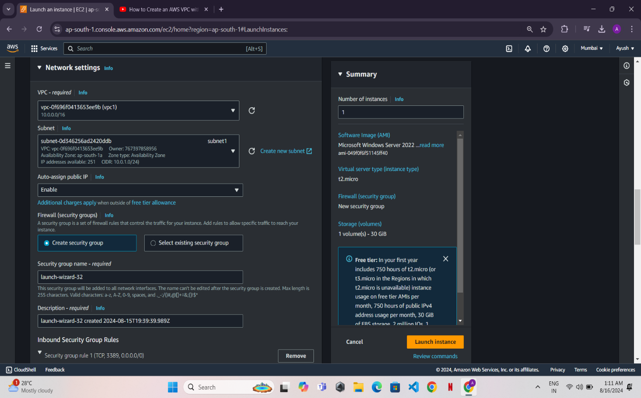

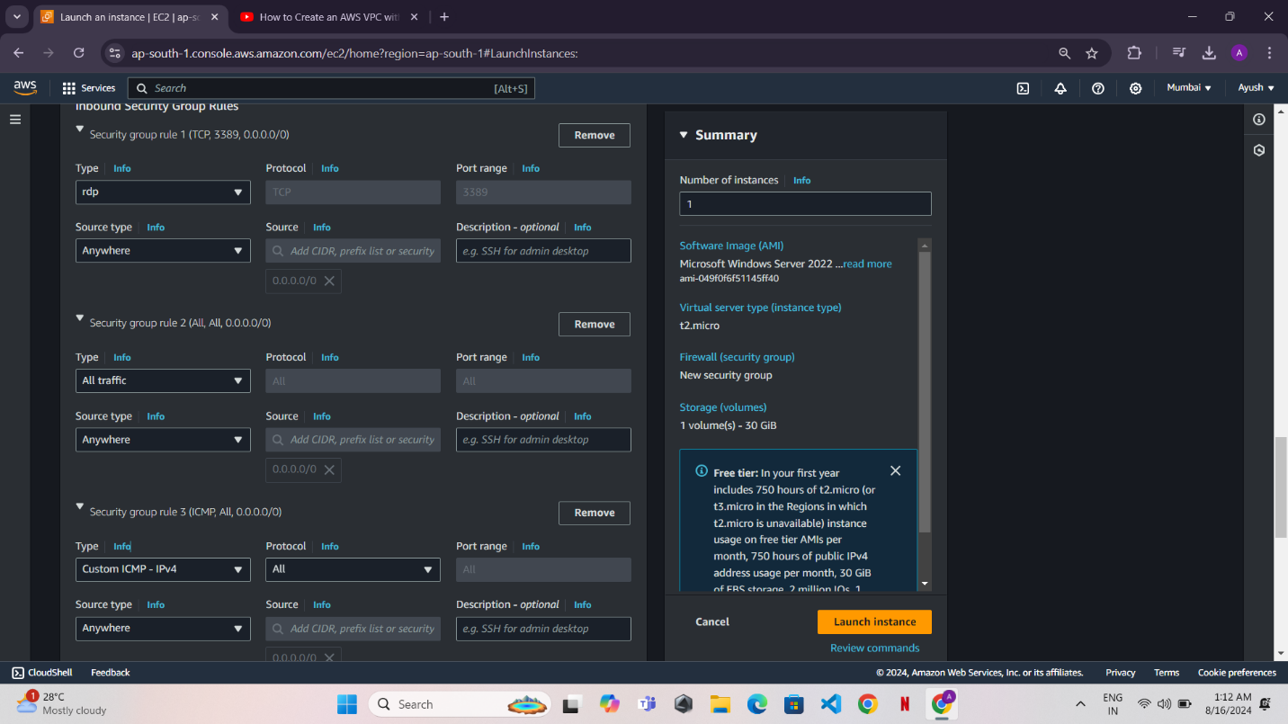

1. Launch: Review and launch the instance using a new or existing key pair.

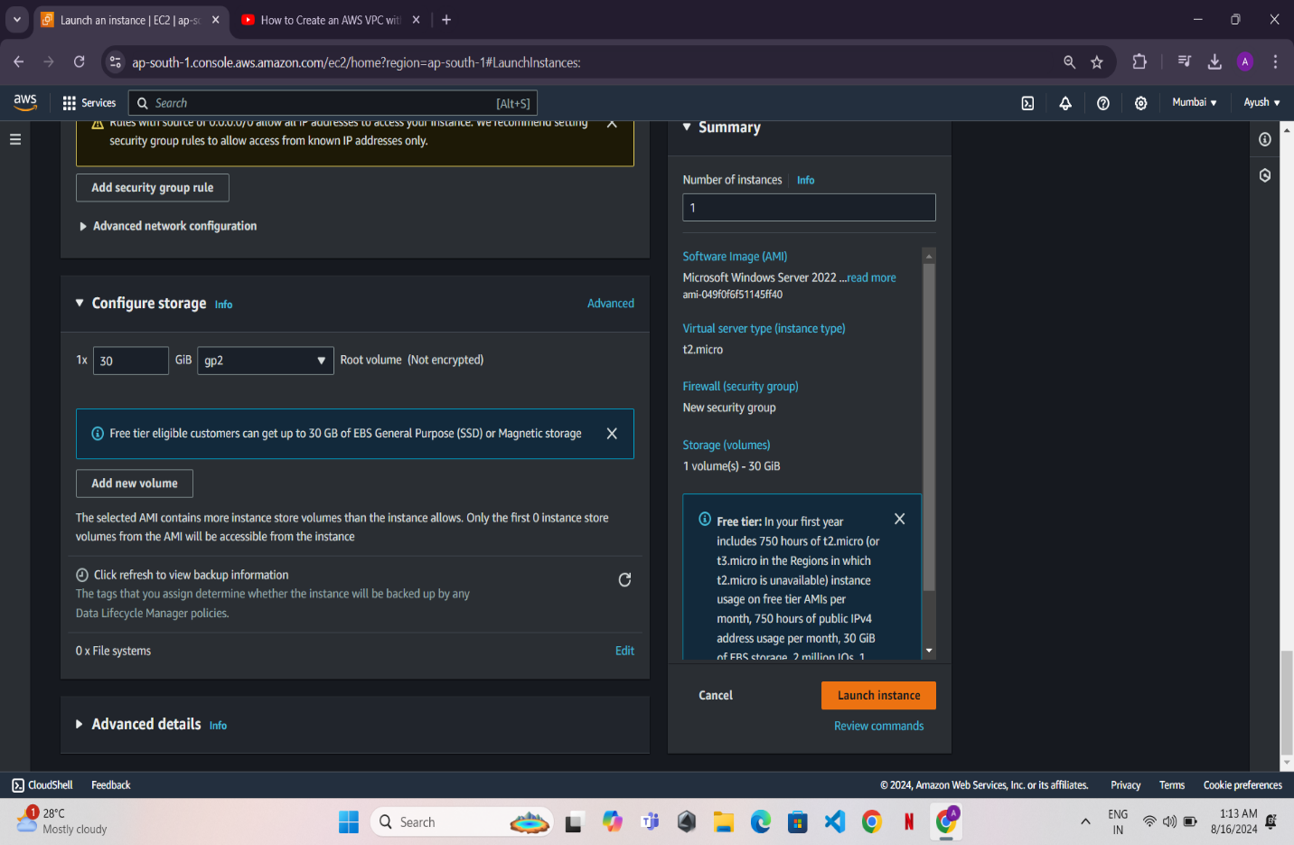

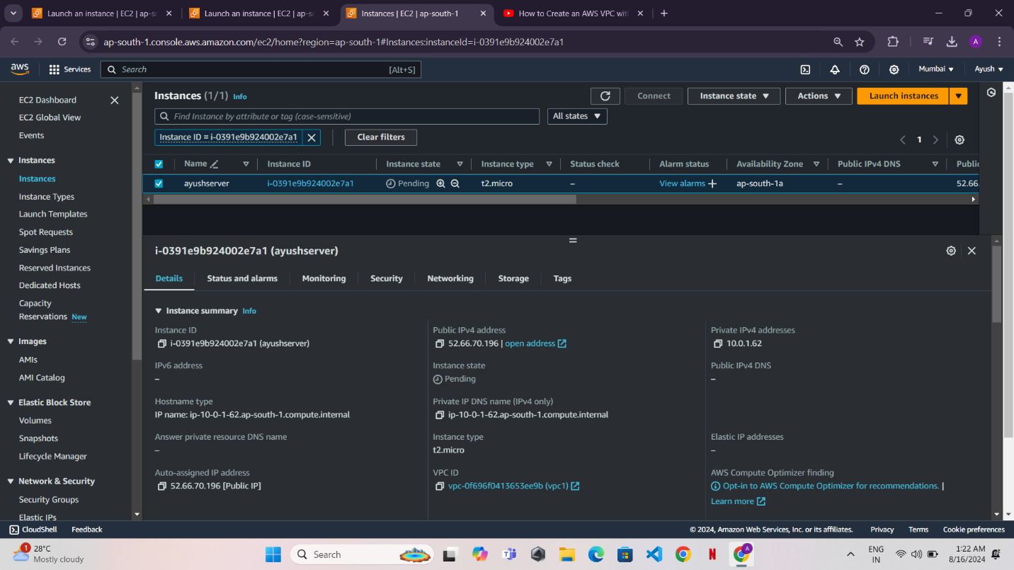

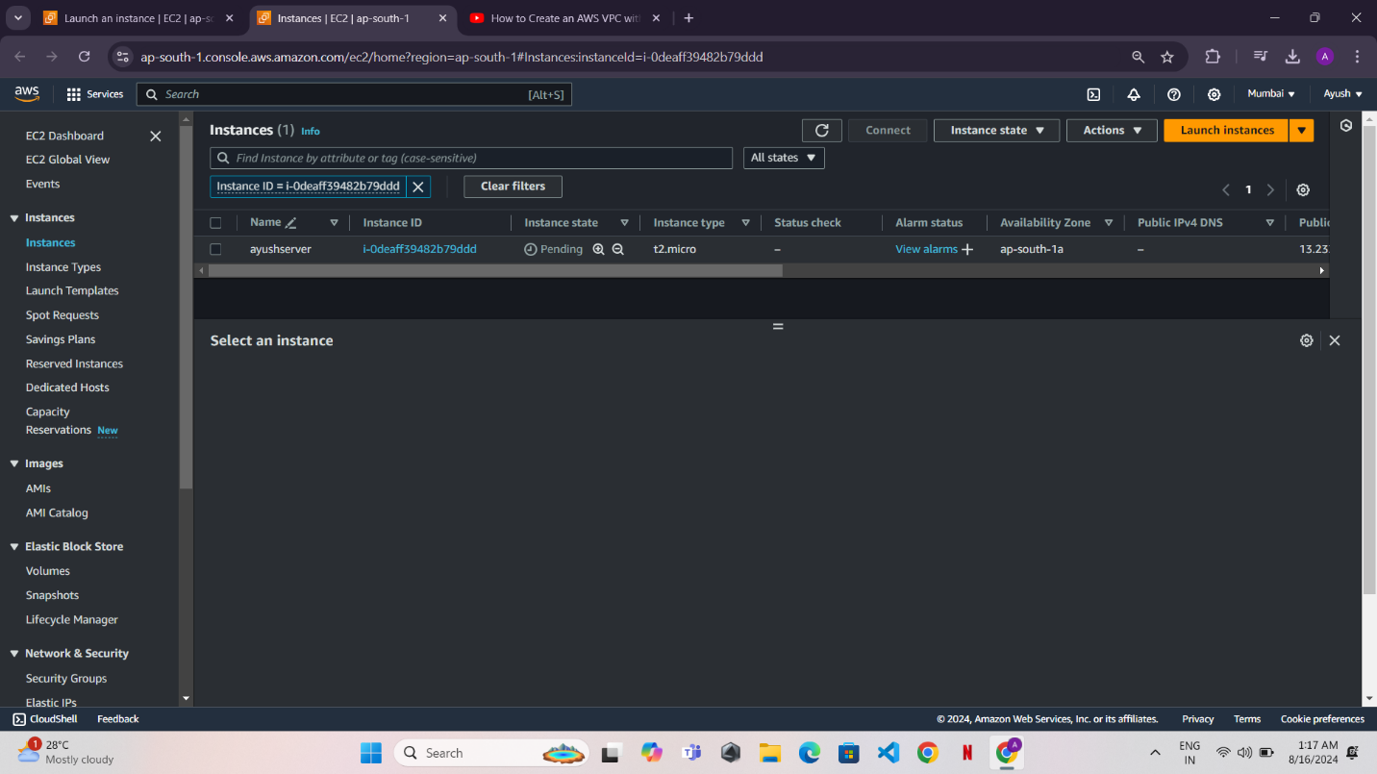

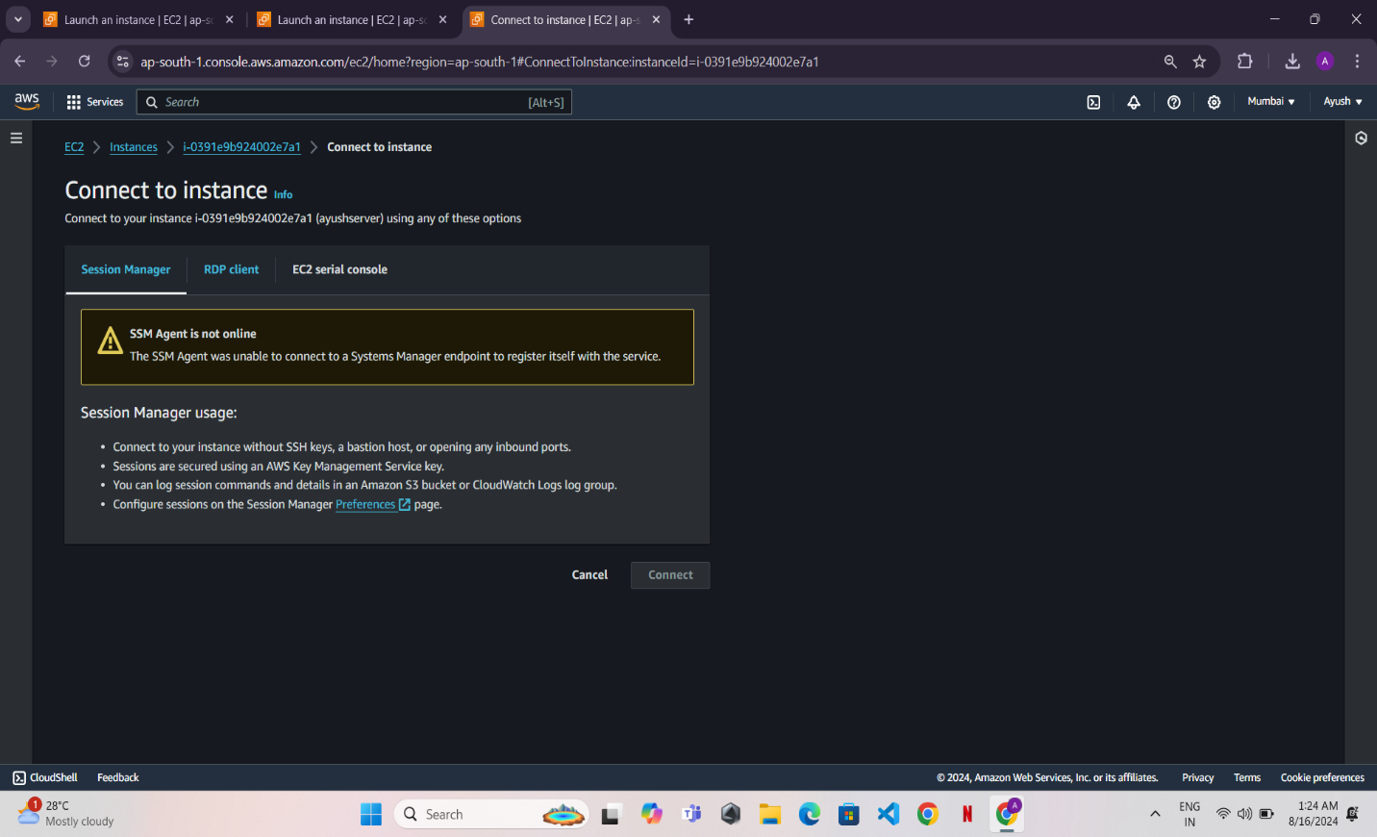

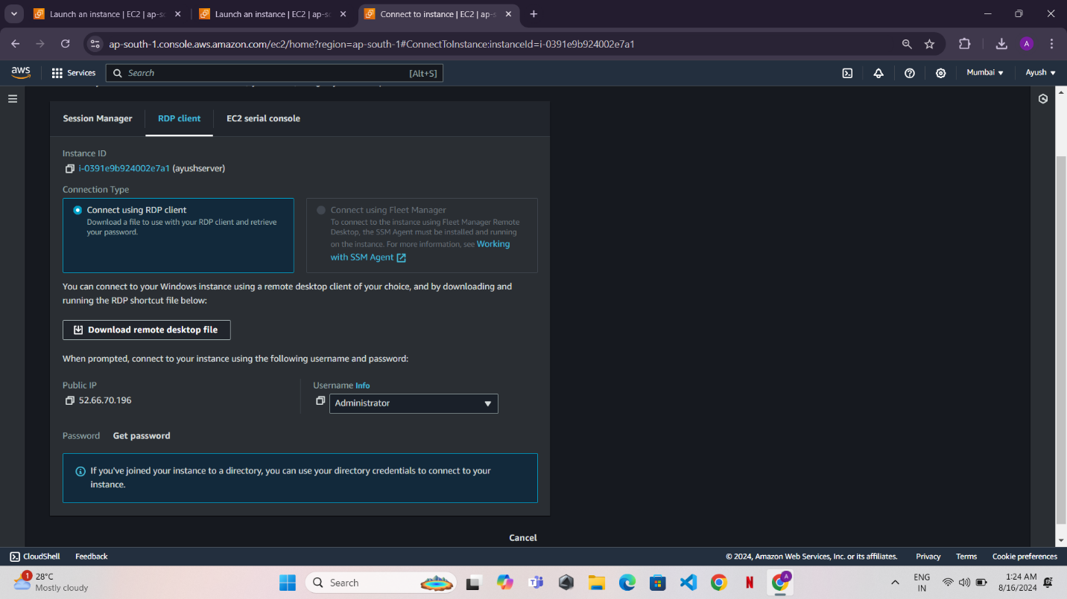

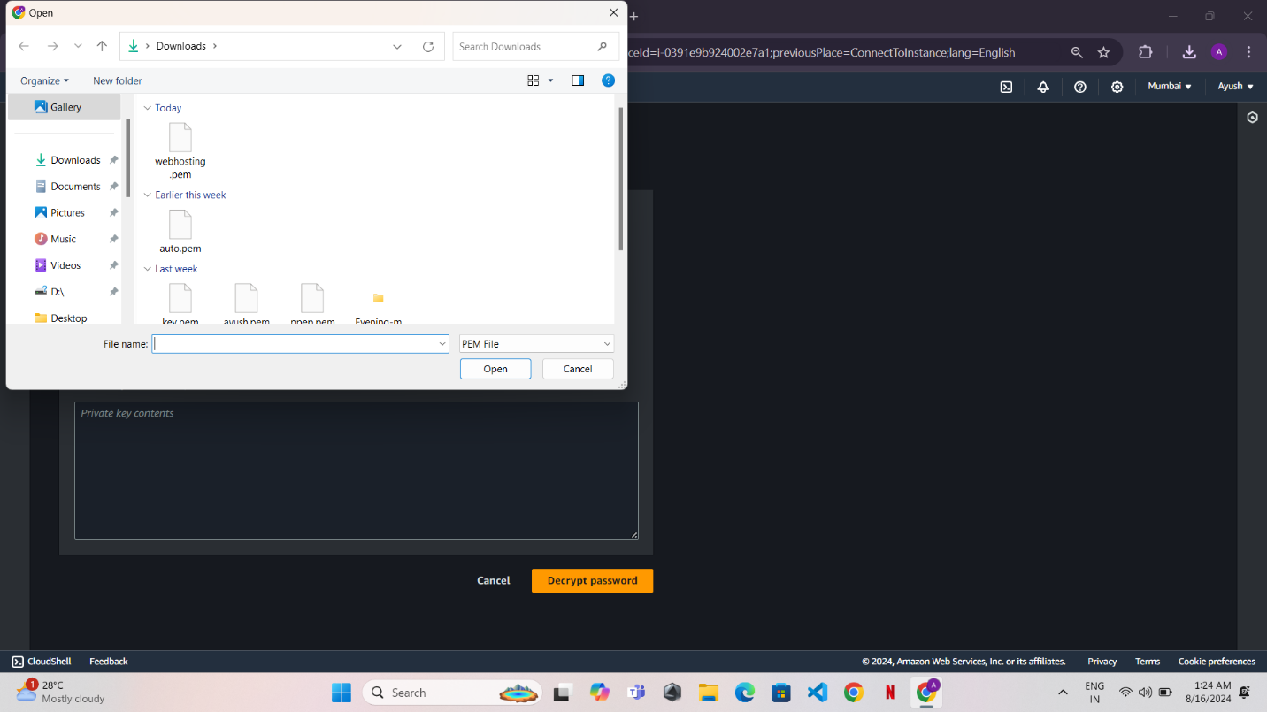

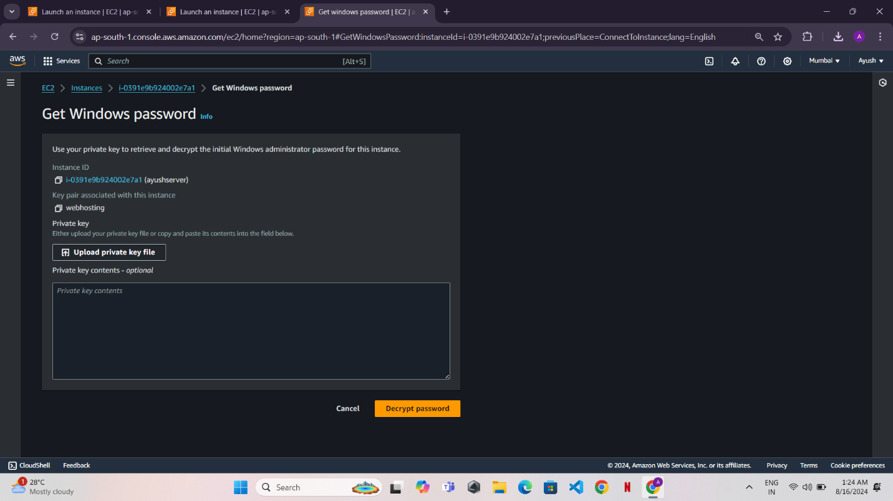

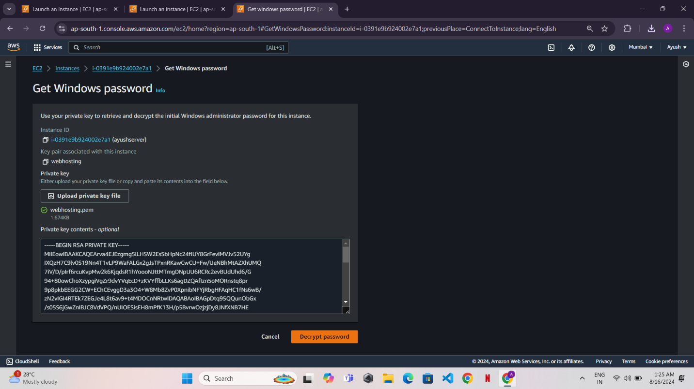

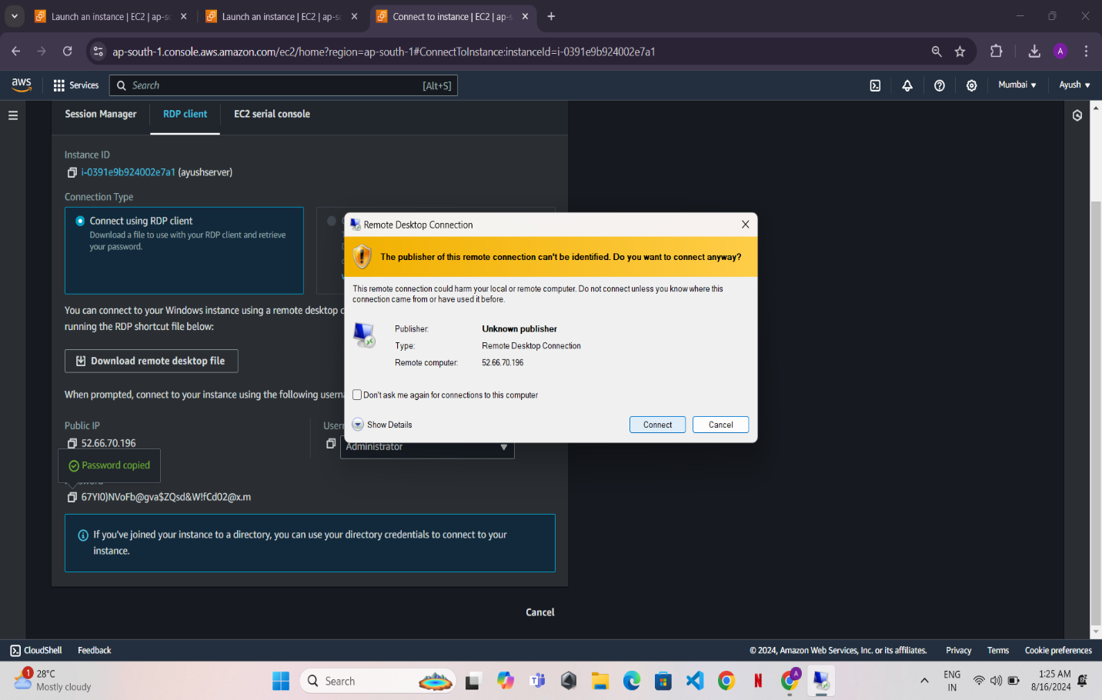

Step 6: Set Up IIS for Web Hosting

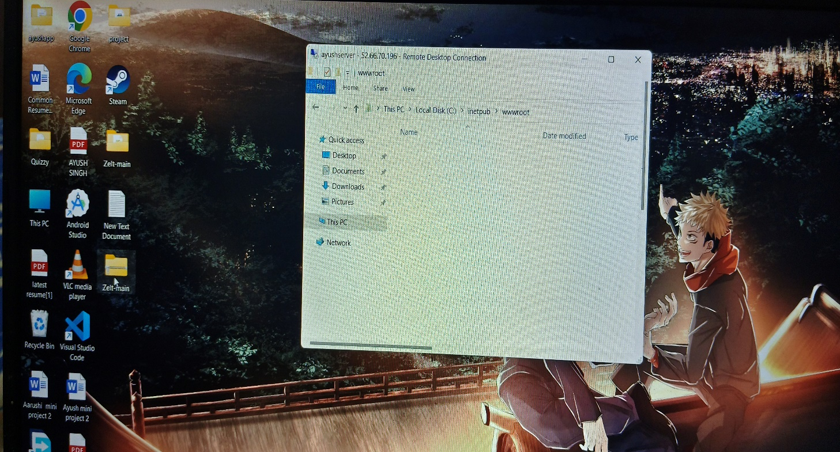

* Install IIS (Internet Information Services):
* Open Server Manager.
* Add Roles and Features > Select Web Server (IIS) > Complete the wizard

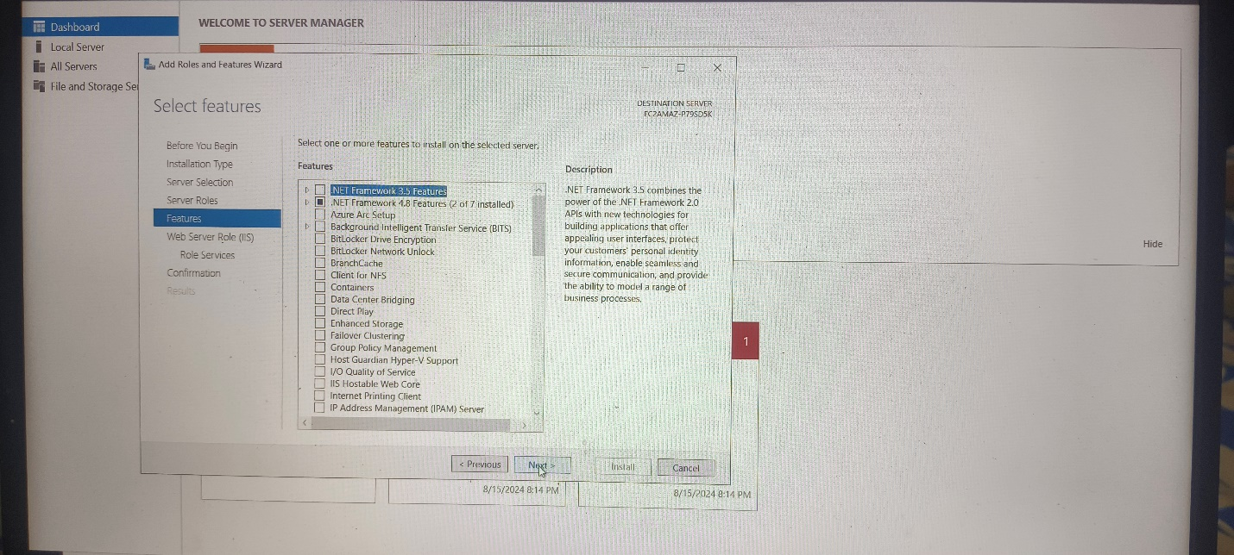

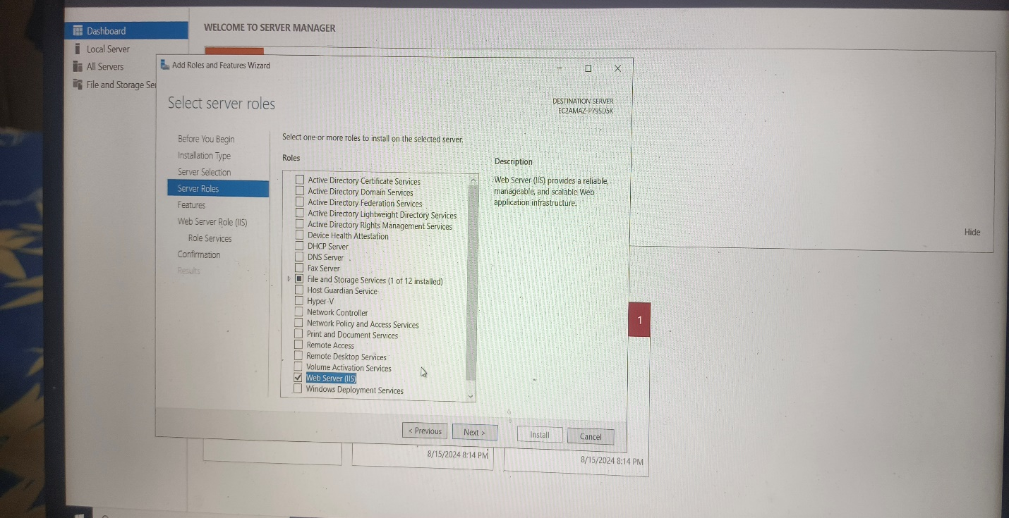

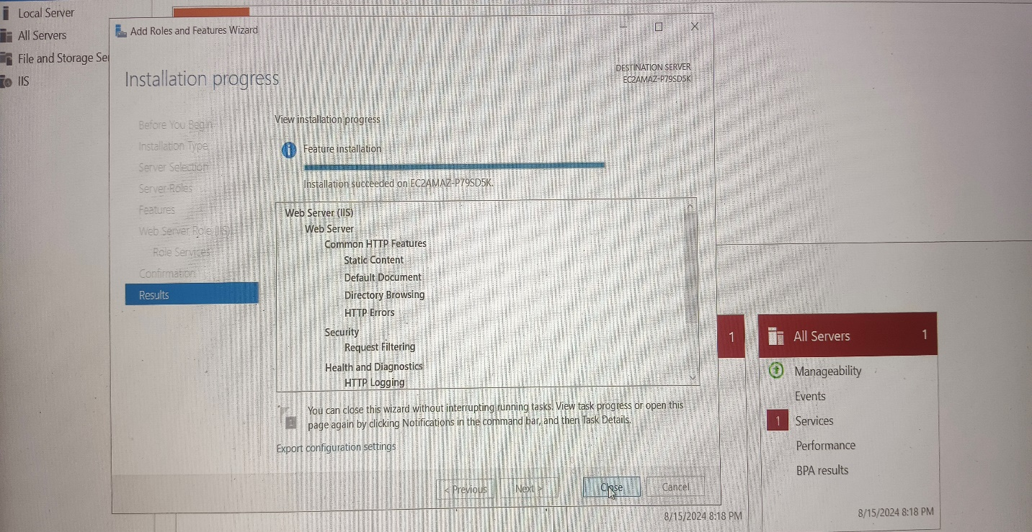

* Place your web content in C:\inetpub\wwwroot.
* You can test it by accessing the instance's public IP in a browser.

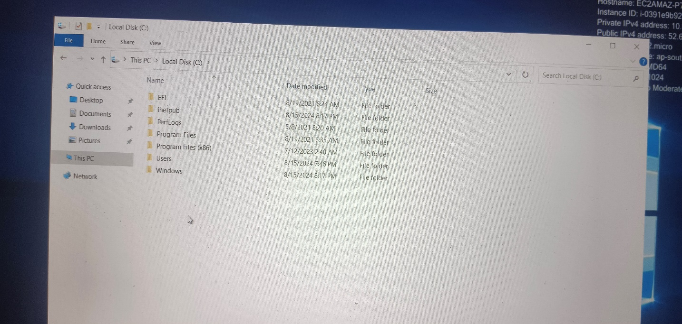

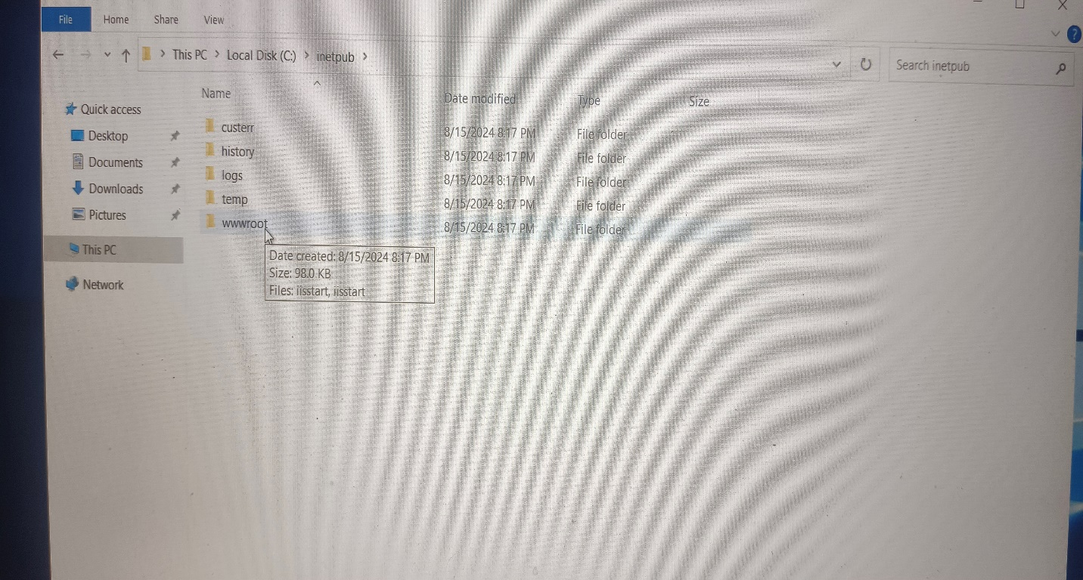

* Now delete all the contents from wwwroot

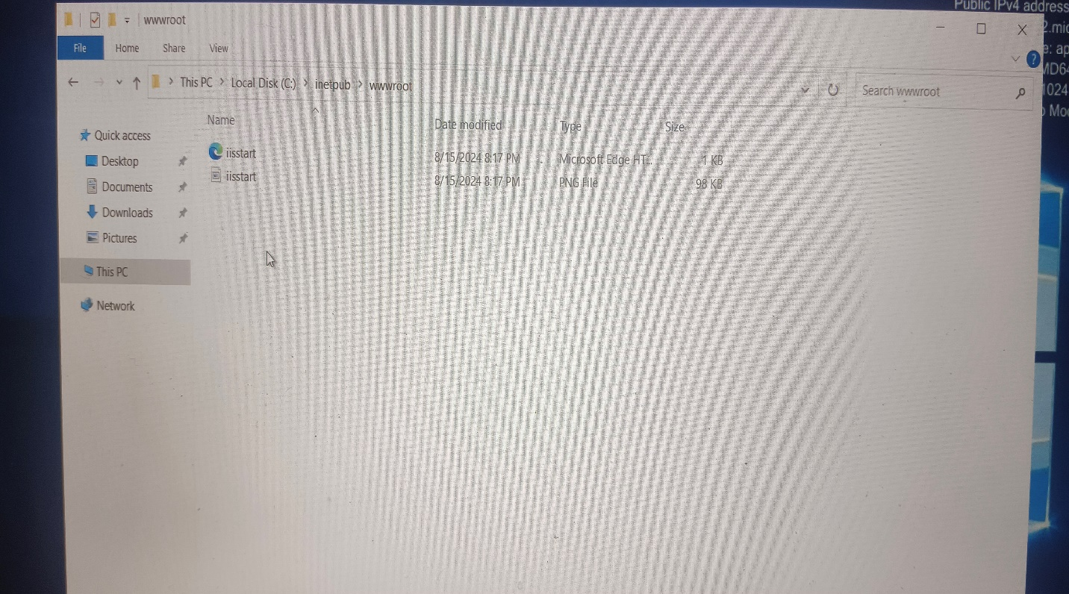

* Copy the website and paste in the wwwroot

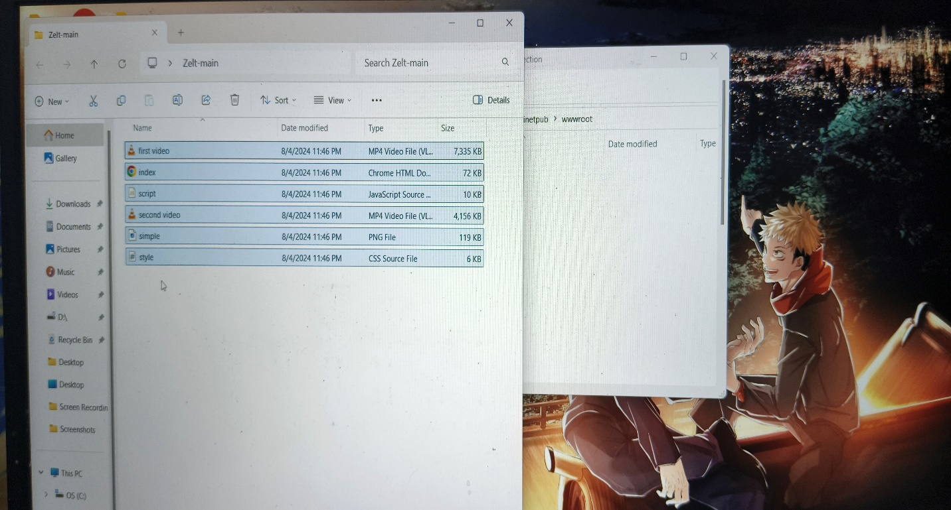

* Copy the Public ip address and paste in the next tab of the browser

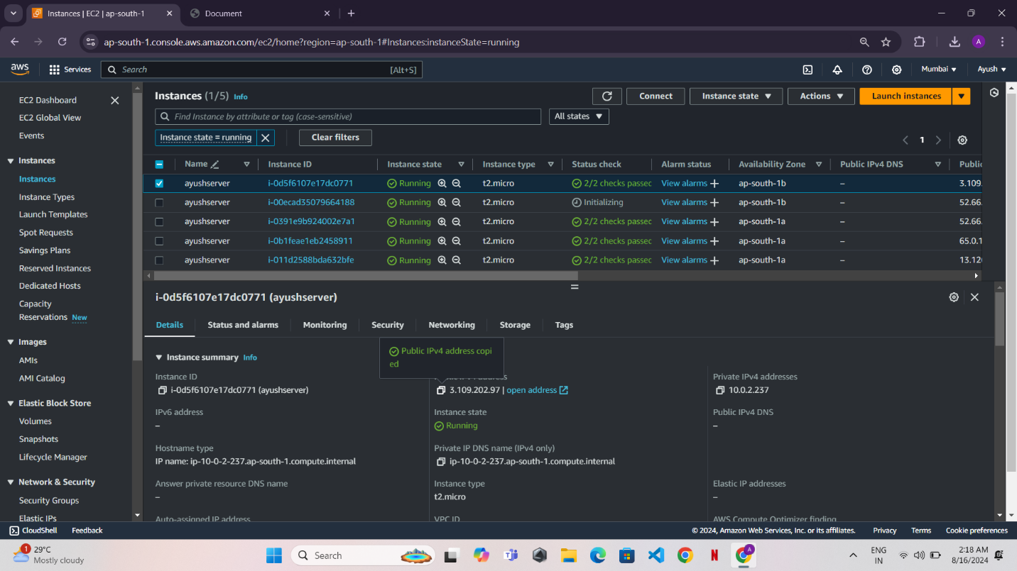

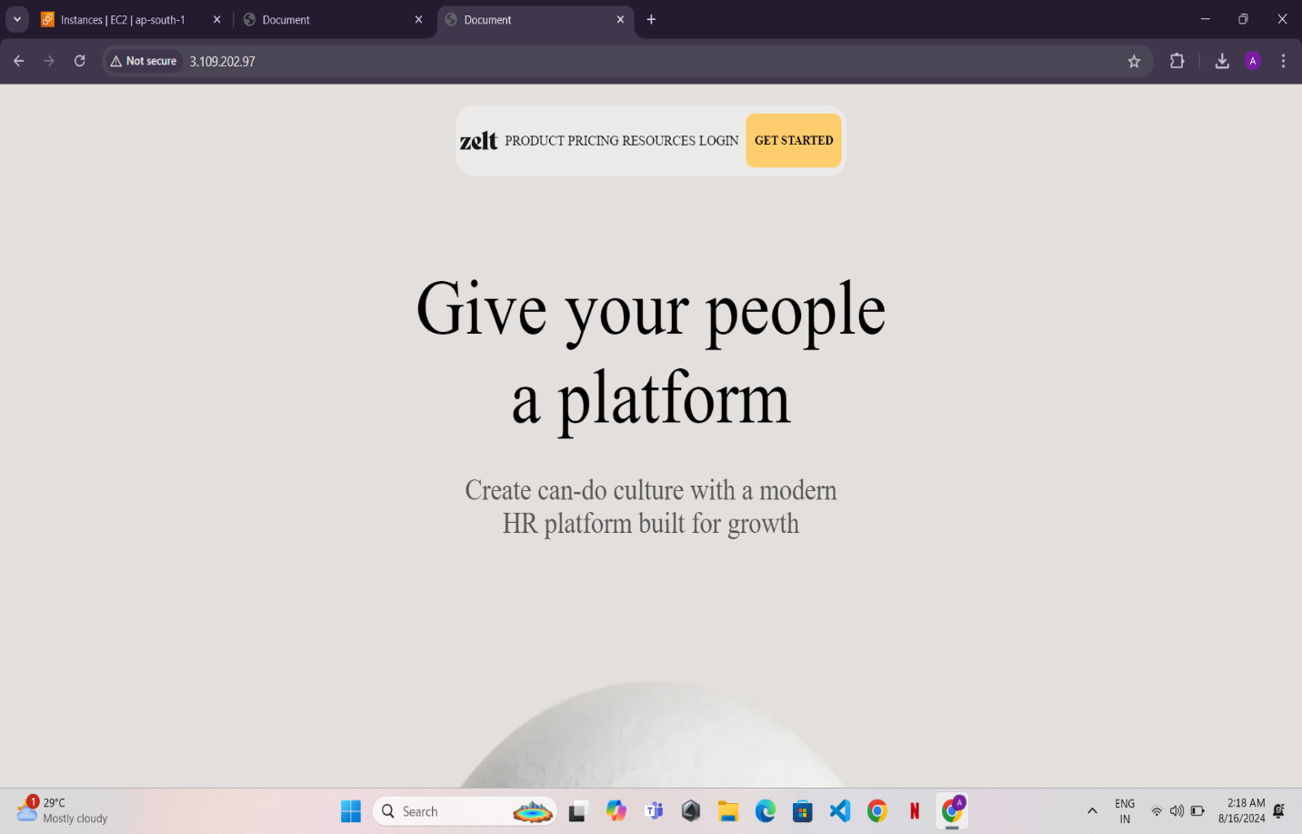

Step 7: Create an AMI

* Go to the EC2 Dashboard.
* Select the running instance, click Actions > Image and templates > Create Image.
* Name the image and provide a description. Click Create Image.

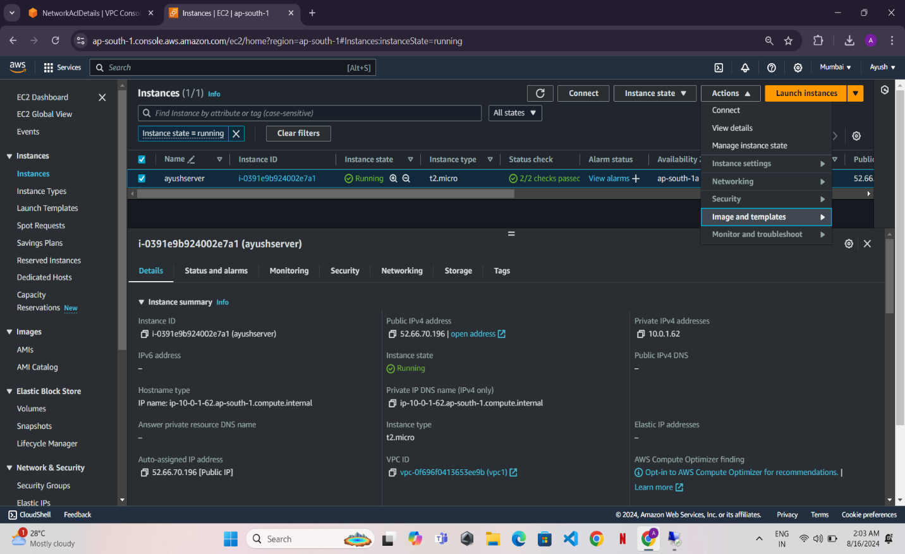

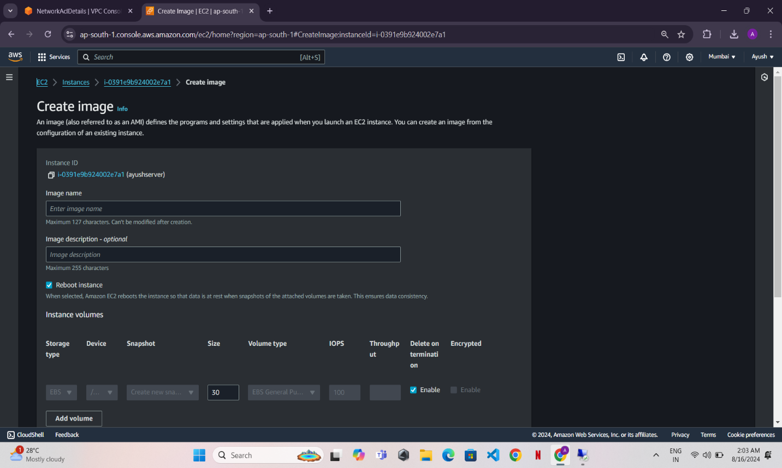

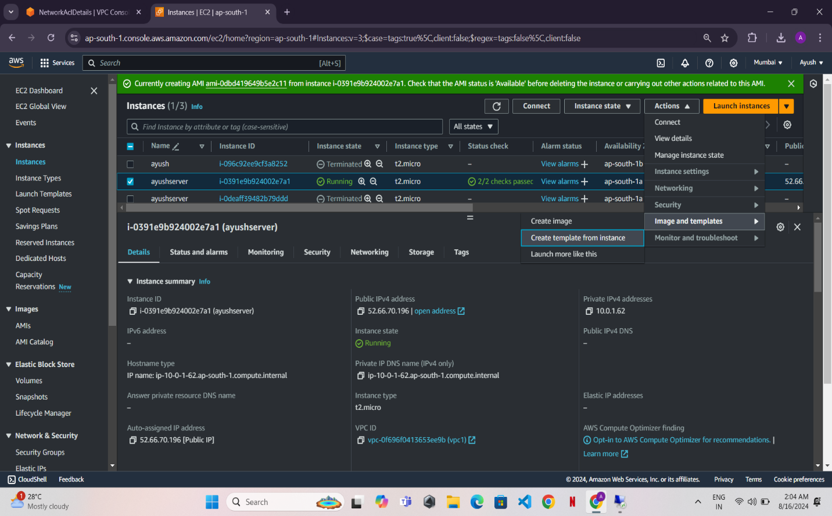

Step 8: Create a Launch Template

Go to the Launch Templates section under the EC2 Dashboard.

Click Create Launch Template.

Name the template, choose the AMI you created, and configure other settings like instance type, key pair, security group, and user data.

Click Create Launch Template.

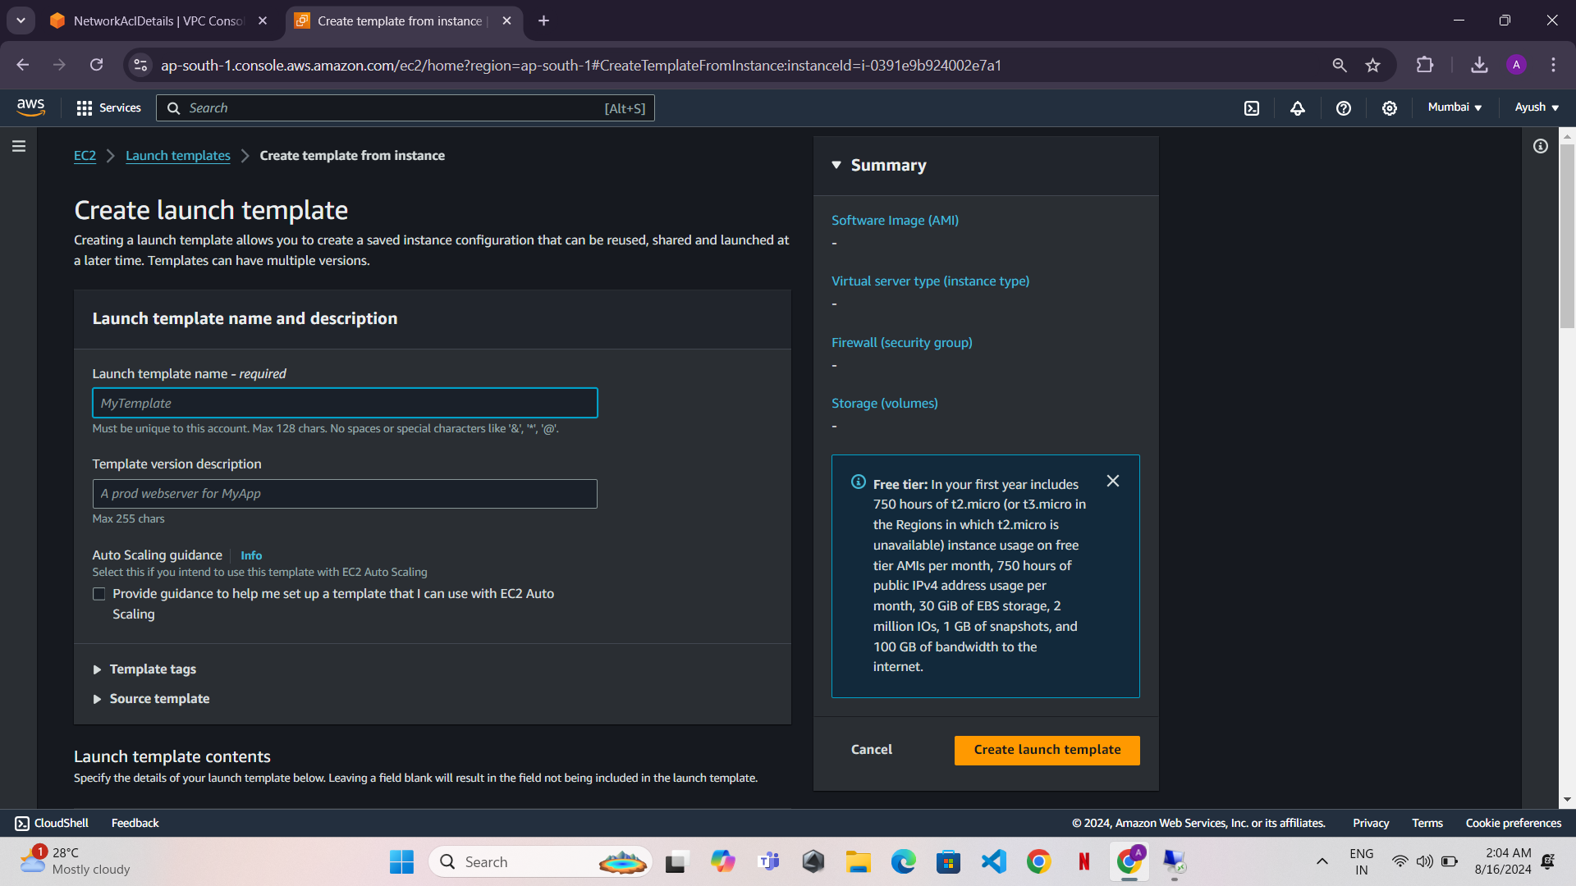

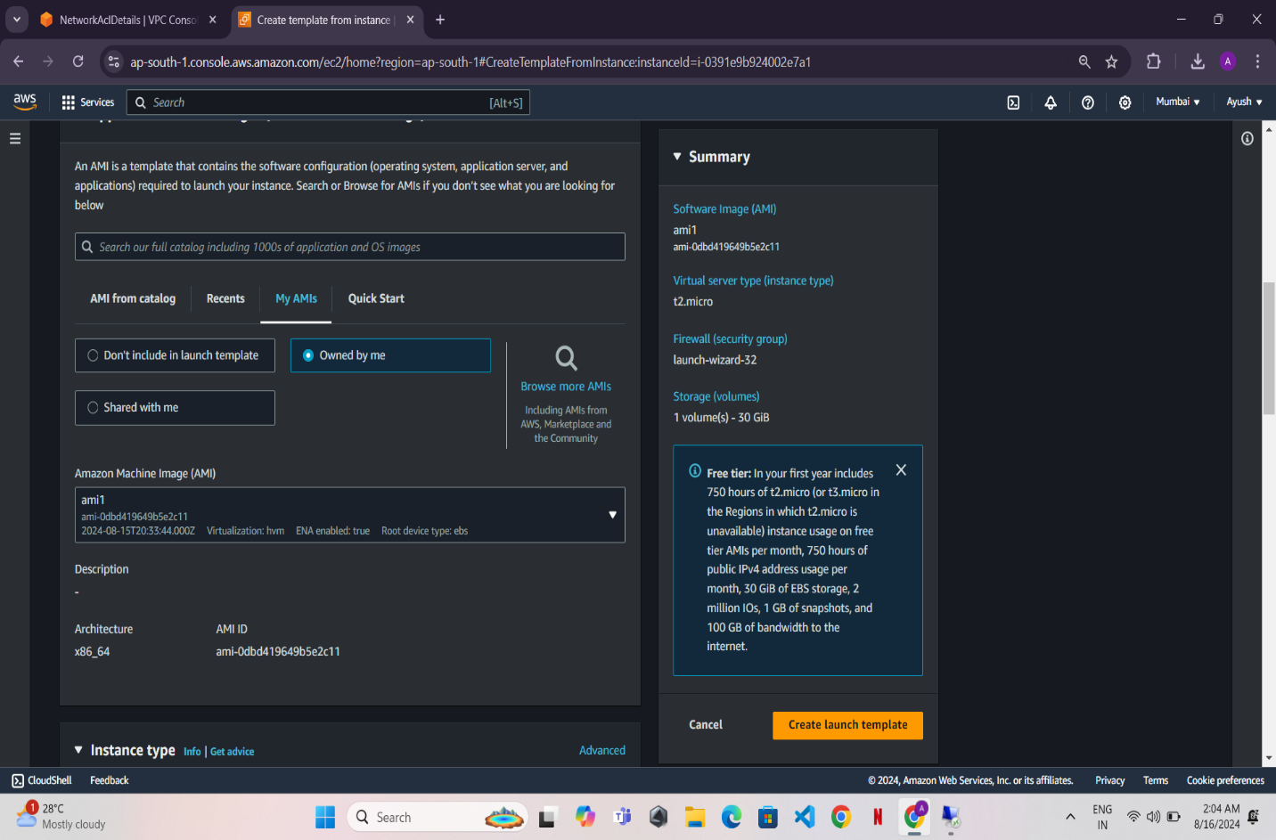

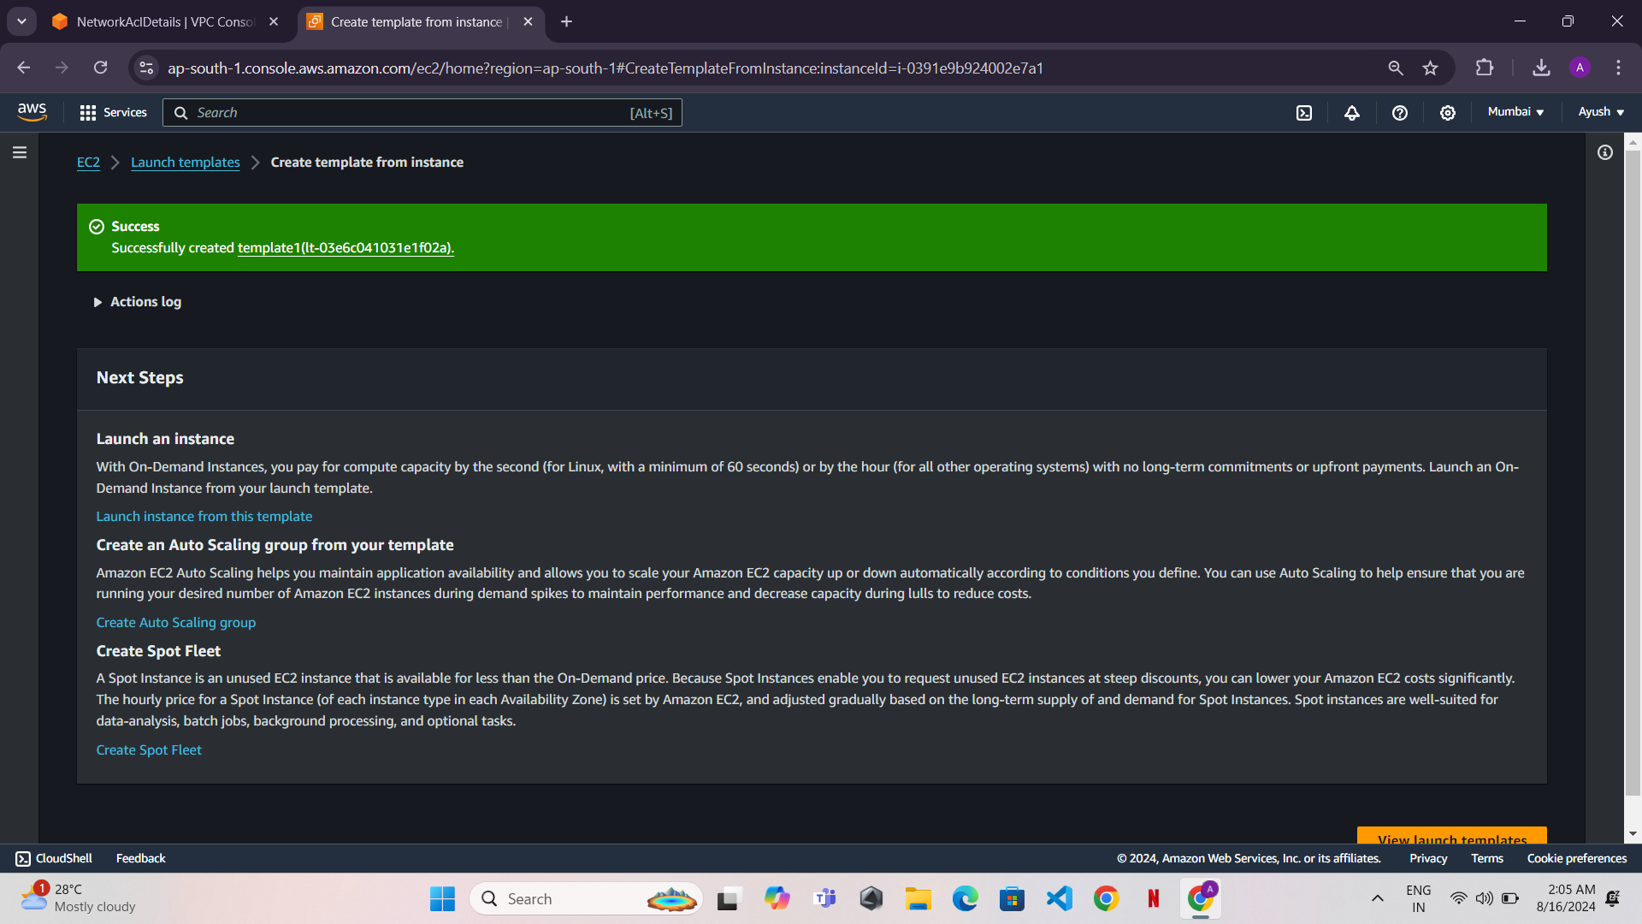

Step 9: Create an Auto Scaling Group

* Go to the Auto Scaling Groups section in the EC2 Dashboard.
* Click Create Auto Scaling Group.

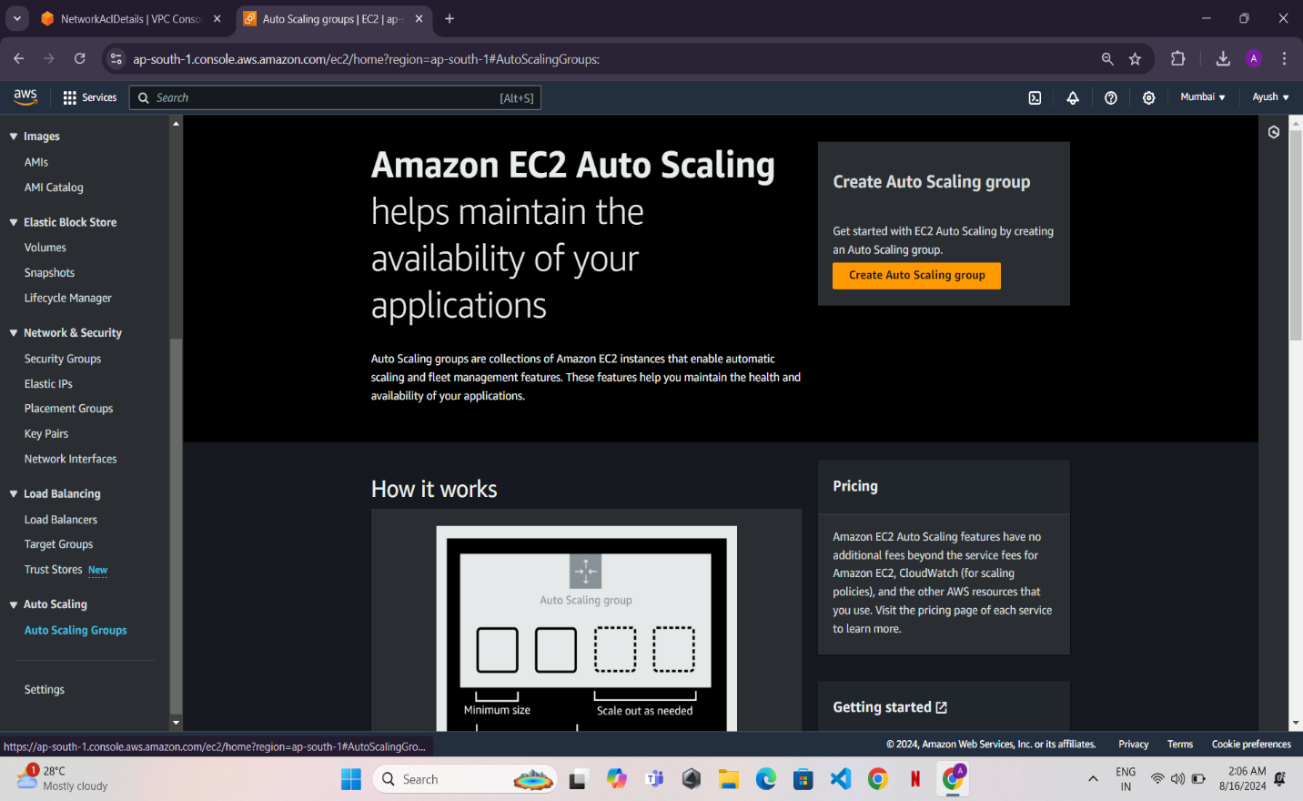

* Name the group, choose the launch template you created, and select the desired VPC and subnets (private subnets for back-end instances).
* Configure desired capacity, min/max instances, and scaling policies.
* Click Next to review and create the Auto Scaling Group.

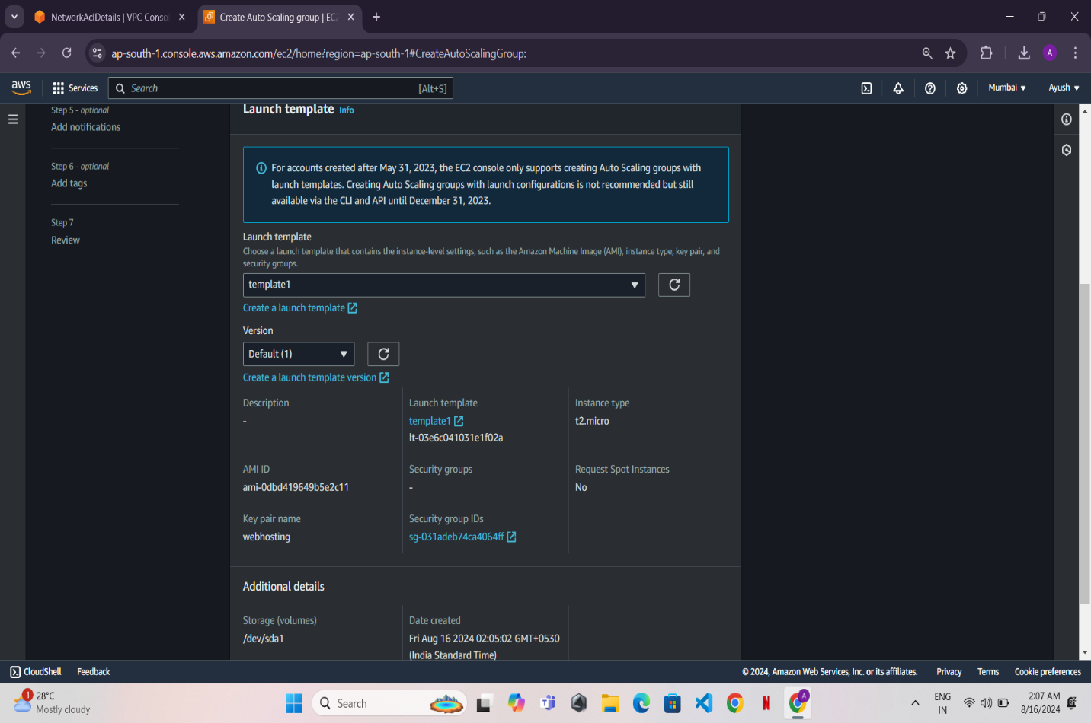

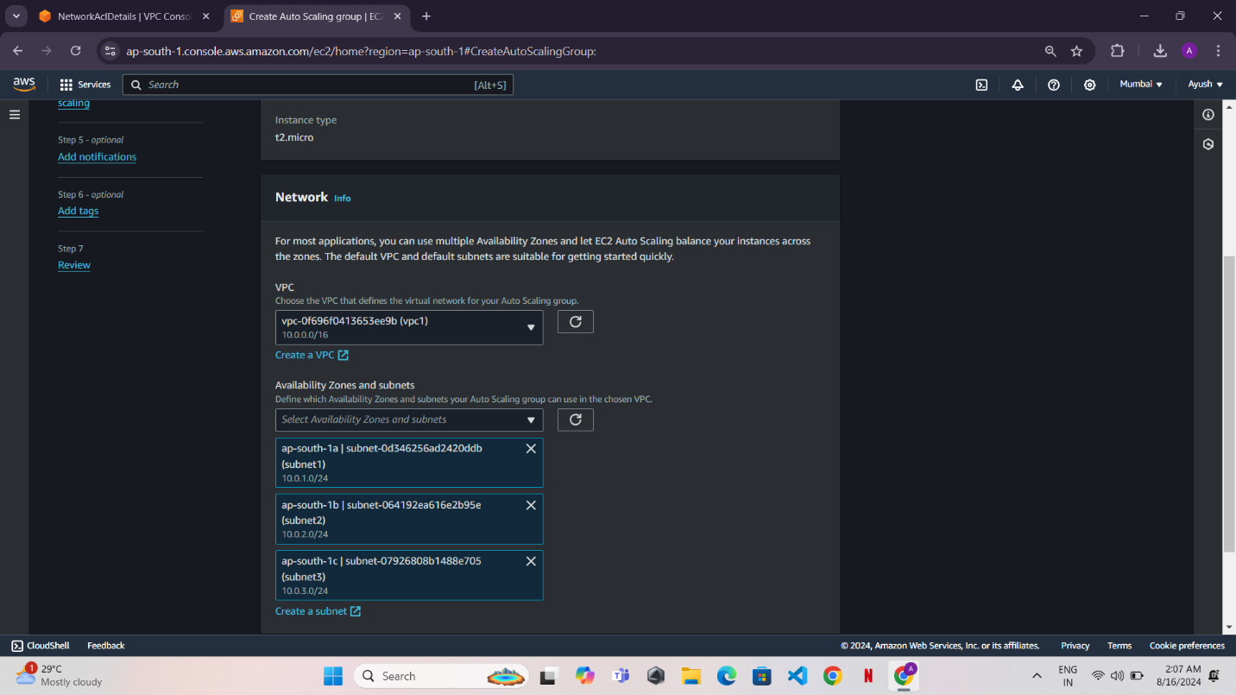

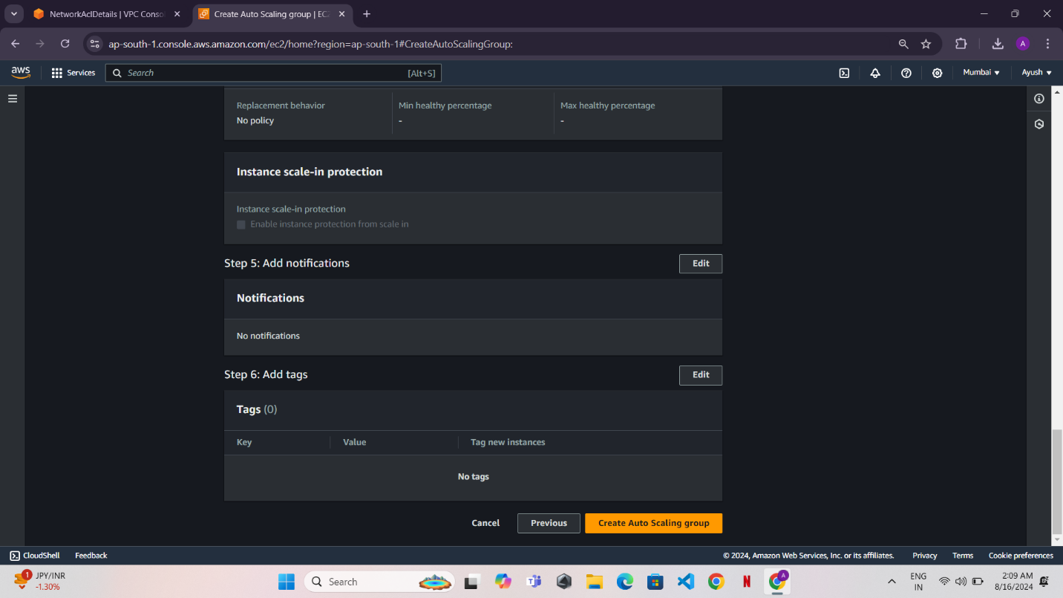

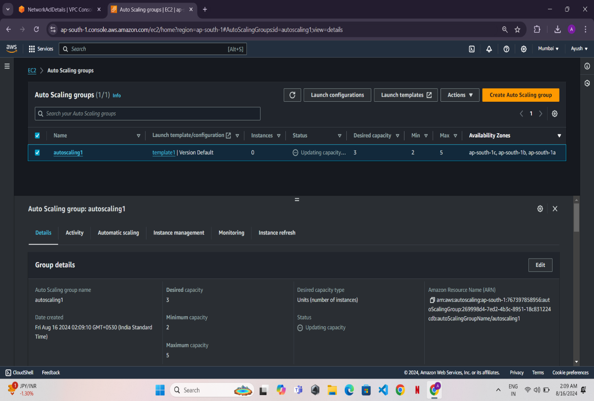

Step 10: Set Up a Load Balancer

* Go to the Load Balancers section in the EC2 Dashboard.
* Click Create Load Balancer and choose Application Load Balancer.

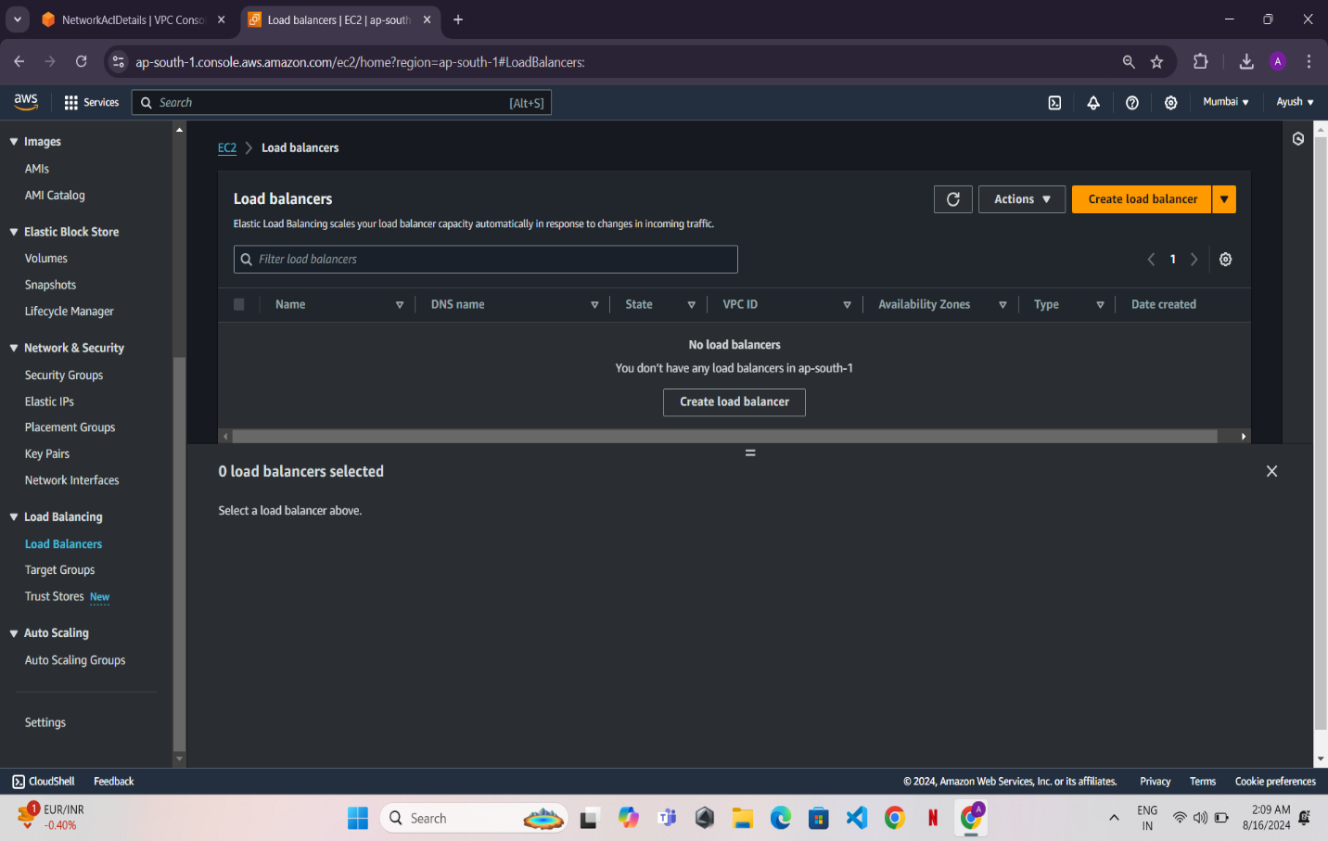

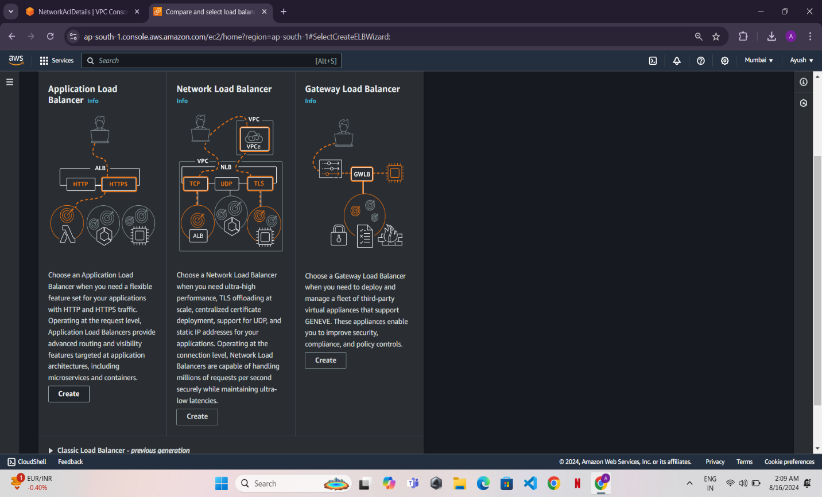

* Name it, select the VPC, and choose the subnets where the instances are running (typically private subnets).
* Configure the security group to allow traffic (HTTP port 80).
* Create a target group and register your EC2 instances.
* Review and create the load balancer.

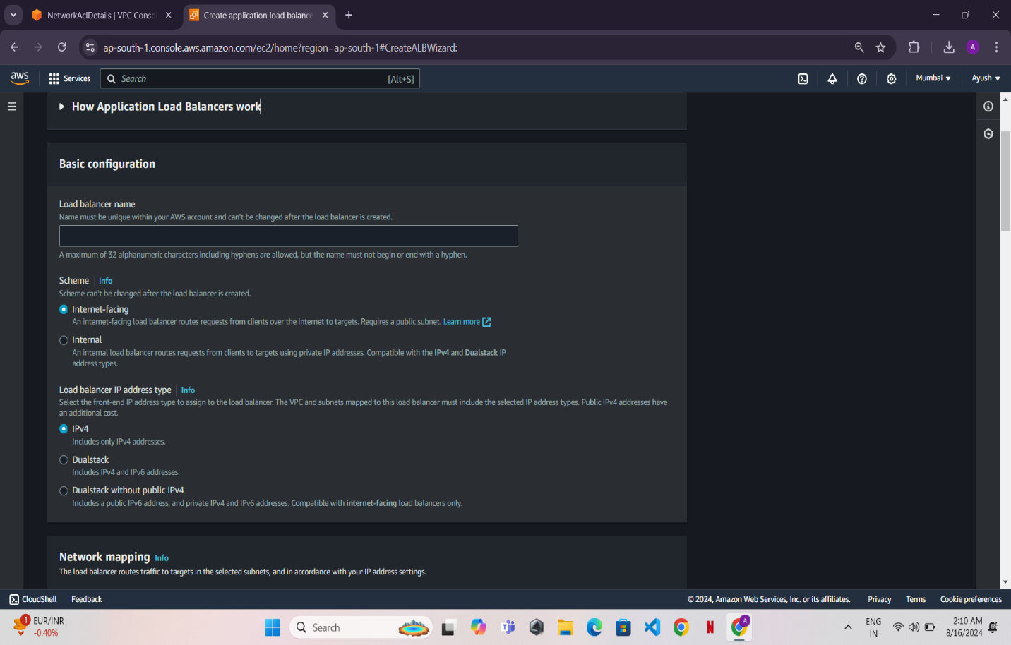

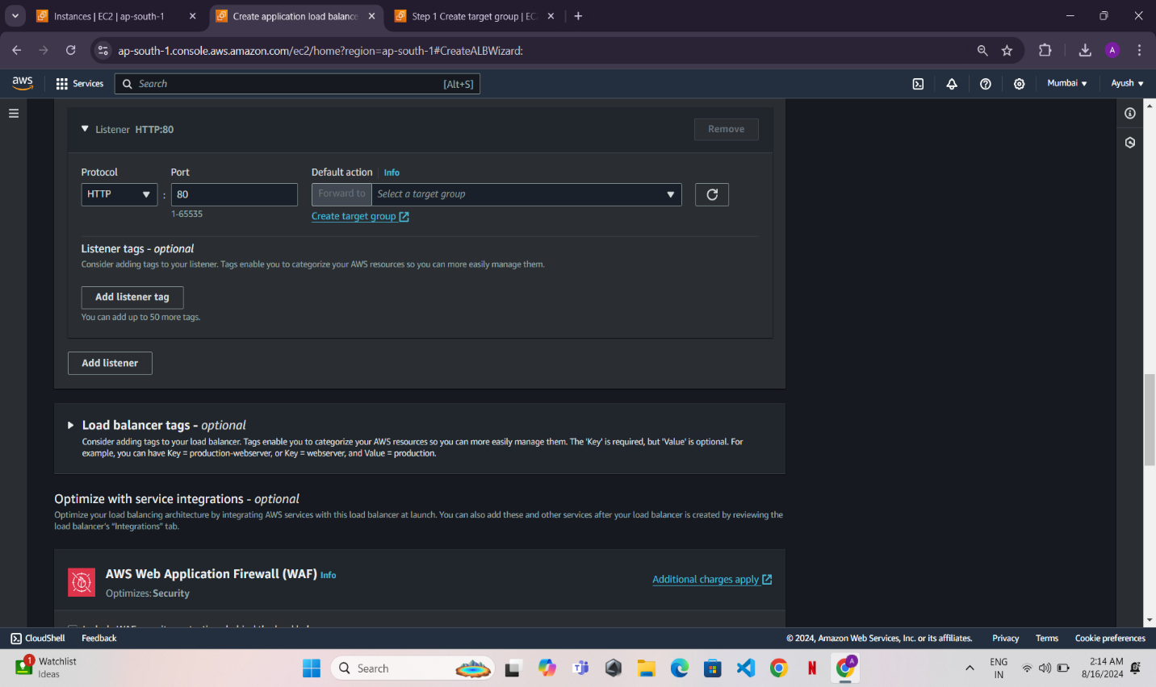

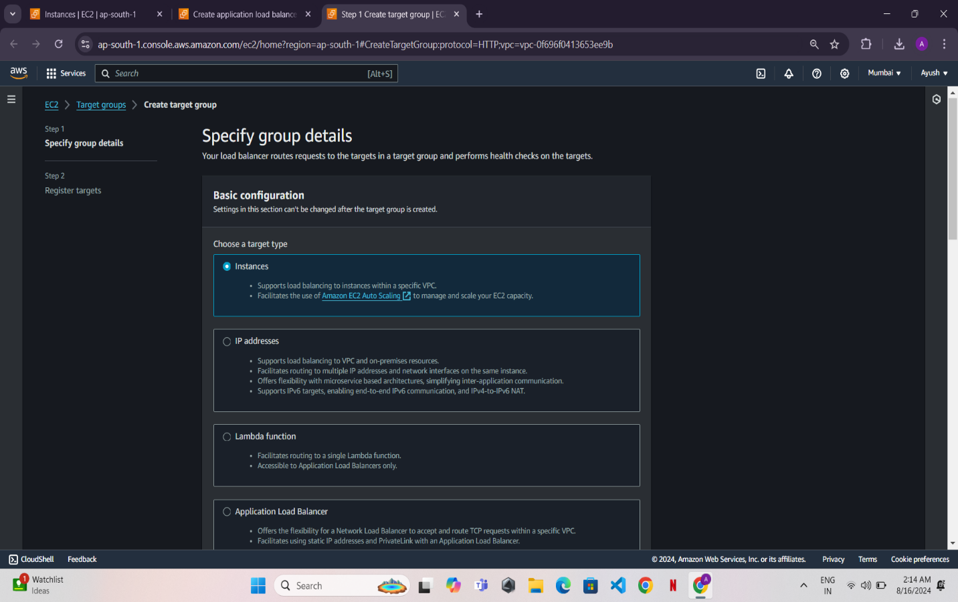

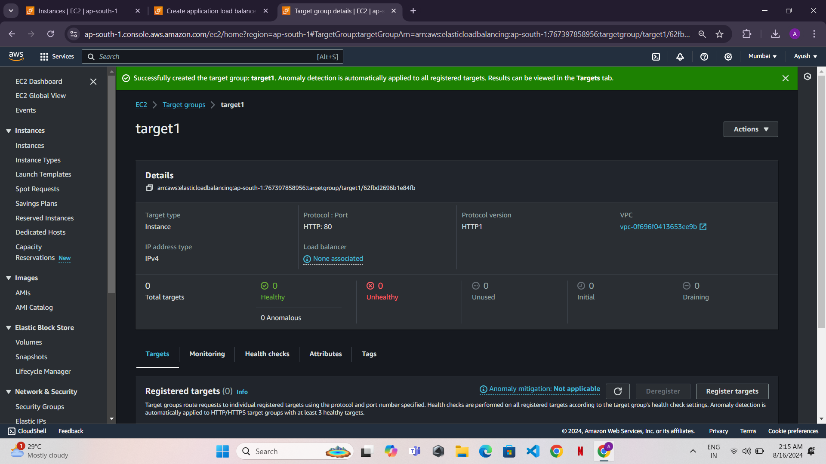

We successfully created the load balancer.

* Summary
* VPC and Subnets: Set up a custom VPC with three subnets.
* EC2 Instance: Launch a Windows instance and set up IIS for web hosting.
* AMI: Create an AMI from the configured instance.
* Launch Template: Set up a launch template for future instances.
* Auto Scaling and Load Balancer: Configure auto-scaling to manage instances and distribute traffic using a load balancer.
* This comprehensive setup will give you a scalable, load-balanced web hosting environment on AWS using Windows EC2 instances.